Action Research
Proposed by Kurt Lewin in the 1940s; the classic model is often called Lewin's action research spiral model.

- Diagnosis: motivation and problem identification. Why are we carrying out this outreach? What information are we missing? What gaps does the project have? What questions do we need to ask professionals?
- Plan: design the interviews and the outreach plan. Identify the interviewees (stakeholders: teachers, industry practitioners, potential users), design the interview outline, and decide how information will be collected.
- Act: carry out the interviews and collect feedback. Conduct the interviews, record the interviewees' views, and compile all opinions.
- Observe & Reflect: evaluate and iterate the project. Analyze all feedback, assess the feasibility of the suggestions, and revise our project plan, experimental design and application concept; after one round ends, identify new problems and move into the next cycle.

Overview
Influenza A is a seasonal influenza disease that usually breaks out during specific periods each year. Although the outbreak period is limited, influenza A imposes an extremely heavy global disease burden during each epidemic season. According to World Health Organization (WHO) reports, each year there are about 3–5 million severe cases and 290,000–650,000 influenza-related respiratory deaths. Influenza A does not originate in humans but comes from poultry, and influenza transmitted from poultry to humans has another name, “avian influenza”, such as “H5N1”. Avian influenza itself can only infect a small number of humans and cannot continue to spread from person to person, but it has undergone a terrifying change in pigs. This is because the respiratory tract of pigs carries both avian α-2,3 and human α-2,6 receptors. And by an unfortunate coincidence, when the same pig is infected with both avian influenza and an already circulating human influenza, the eight RNA segments of the two viruses reshuffle and reassort, directly producing a completely new strain. The new strain may at once acquire the ability to recognize human receptors, to replicate in human cells and to spread from person to person. Influenza A epidemics have a distinct cyclical character: after the peak of an epidemic, case numbers fall rapidly and public vigilance gradually fades; but by the next epidemic season, the mutated influenza A virus returns, once again threatening human health.

To improve influenza A prevention and control, we hope to use synthetic biology to capture and detect influenza A virus, and this is how our project, Echo Yeast, came about. To build a device that is practically applicable and socially valuable, we cannot confine ourselves to theoretical reasoning and experimental validation inside the laboratory; we need to work with people outside, improving our project through the questions and suggestions of experts so that it matches the real conditions and needs of society. We first mapped out our project's stakeholders, including pulmonology clinicians, frontline nurses, researchers and institutional staff. The suggestions they raised provided a realistic basis for our project concept, guided the optimization of our approach, offered ideas for model construction, and refined the device's application scenarios and many practical details. It is precisely with the help of experts from all walks of life that our project design is able to fit actual user needs more closely.

Framework
To carry out rigorous, well-organized and genuinely valuable outreach, a sound guiding framework is indispensable. With such a framework, we have a clear line of thinking whenever outreach is needed, and we can adjust our strategy in a more orderly and convenient way during that outreach.
We referred to the Action Research model, which was proposed by Kurt Lewin in 1940; specifically, we applied Kurt Lewin's Action Research Spiral Model.

The distinguishing feature of this model is that it is not a closed circle but a rising spiral: the end of each cycle is the beginning of the next plan. It also embodies the unity of knowledge and action — we research through continuous outreach and then carry out more outreach through research, binding our project closely to reality.

Where knowing is genuine and earnest, that is acting; where acting is clear-sighted and discerning, that is knowing. The effort of knowing and acting can never be separated.
— Wang Yang, Chuanxilu (Records of Instructions for Practical Living)

Diagnosis: identify the problem and the motivation. What is the purpose of this outreach, and what is the core question of this interview?
Plan: design the plan for this outreach and confirm the interviewees; what information might we obtain from them?
Act: begin the interviews, collect feedback, and record the interviewees' views and opinions.
Observe & Reflect: analyze the feedback, revise and iterate the project design, and apply the feedback in practice. After this round ends, start identifying new problems and enter the next cycle.

Stakeholder
Clinical care and end-user needs (Wang Wenjie, Fu Kai, Deng Manqing)
Public health and regulation (Fang Shisong, Luo Yiwu)
Academic research and technical advisors (Qiu Xinyuan, Luo Zhouqing, Wu Hui, Jia Honghua, Zhang Haili, Huang Linsen)
Education and outreach (Shenzhen First Vocational Technical School; freshman outreach)
Industrial translation and commercialization (Deng Rongkang)
Internal project support (Liu Xiaolong)
Academic community and peer exchange (online yeast workshop, APiC, South China meetup)

List of interviewees
Wang Wenjie, Director of the Medical Technology Department at a Grade II Class A hospital in Shenzhen
Fu Kai, MD in clinical medicine, Sun Yat-sen University
Deng Manqing, pediatric clinician at a Grade III Class A hospital in Shenzhen
Deng Rongkang, manager at a biotechnology company in Shenzhen
Qiu Xinyuan, synthetic biology expert
Fang Shisong, Deputy Director of the Pathogen Institute, Shenzhen Center for Disease Control and Prevention
Luo Zhouqing, Professor at Xiamen University
Luo Yiwu, Shenzhen Health Commission
Wu Hui, Professor at Dalian University of Technology
Jia Honghua, Research Fellow at Nanjing Tech University
Zhang Haili, PhD, Academy of Mathematics and Systems Science, Chinese Academy of Sciences
Shenzhen First Vocational Technical School
2026 freshman outreach
Liu Xiaolong — mathematical modeling section
Huang Linsen
Online yeast workshop

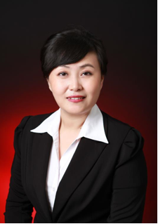
Wang Wenjie
Director of the Medical Technology Department at a Grade II Class A hospital in Shenzhen

Diagnosis:
The project's technical direction and its practical application positioning are still unclear, and the team lacks first-hand knowledge of real influenza A testing scenarios.
Plan:
The team designed interview questions around mutation mechanisms, clinical testing, treatment windows, test-kit updates, application scenarios and the feasibility of self-testing.
Act:
Interviewed Dr. Wang Wenjie to learn about hospital testing logic, the use of specific antiviral drugs, test-kit updates and his suggestions on air monitoring.
Reflect:
We recognized the gap between laboratory models and real needs and decided to focus on the conserved HA stalk region, enclosed-space testing and proactive early-warning applications.

The team had largely settled on its technical route: use engineered yeast as the chassis, display nanobodies on its surface to recognize the conserved stalk region of influenza A virus HA, and build a biosensor that can capture airborne virus and output a detection signal. But a settled technical route does not mean the project is viable; we needed a frontline clinical laboratory expert to assess its practical applicability, and we wanted to talk directly with a clinical laboratory expert to understand the real pain points of influenza A testing in clinical settings, treatment strategies and prevention needs.

Dr. Wang Wenjie pointed out that the existing IVD industry always acts only after the virus has broken out in the human body and reached the detection threshold, whereas our air-monitoring sensor could shift prevention and control from passive diagnosis and treatment to proactive prevention, issuing a warning before the virus enters the body — which has significant public health value. He also identified shortcomings in both the technical and the application side of our project:
- Air monitoring involves many variables, virus concentrations in open environments are low, and the sensor's effective range may be limited.
- The effective range and limiting conditions are still unclear. We need to test the effective measurement range, the size of the environment, the stage the virus is at and so on; otherwise it is difficult to define the real application boundary. (link to the hardware section)
- False-positive and specificity risks are prominent. The false-positive rate of self-test reagents can reach 50%–70%; if the sensor moves toward portable self-testing, specificity and threshold determination must be solved.
- The clinical need for subtyping is limited: hospitals focus on detecting whether the virus is positive or negative in order to guide treatment and do not distinguish subtypes; subtyping is announced by the CDC.
- Translation and standardization are insufficient: the project is still at the laboratory prototype stage, and production, cost, standardization and actual deployment still need to be addressed.

Drawing on frontline experience, the doctor also advised us to focus on “detecting airborne virus” rather than distinguishing subtypes; to test the effective range first in enclosed spaces, controlling invariant factors before studying variables; to clarify limiting conditions such as the effective measurement range, the size of the environment and the stage of the virus; to refer to immunochromatography in developing portable self-testing while strictly controlling false positives; and to actively contact reagent manufacturers to promote translation of the results. In essence, these suggestions require us to fill four categories of data: sensitivity, specificity, environmental adaptability and application boundaries.

The team turned the expert's suggestions into action: first, firmly choose the conserved HA stalk region to achieve broad-spectrum detection and de-emphasize subtype discrimination; second, prioritize the design of enclosed-space experiments and establish a variable-control plan; third, make specificity and false-positive control a focus of subsequent optimization; fourth, define the effective measurement range and environmental limits; and fifth, this interview moved the project from a technical concept toward a problem-driven one and made us keenly aware that a cutting-edge sensor, if it is truly to serve public health, requires not only innovation but also the ability to withstand the test of clinical scenarios, environmental variables and real-world use.
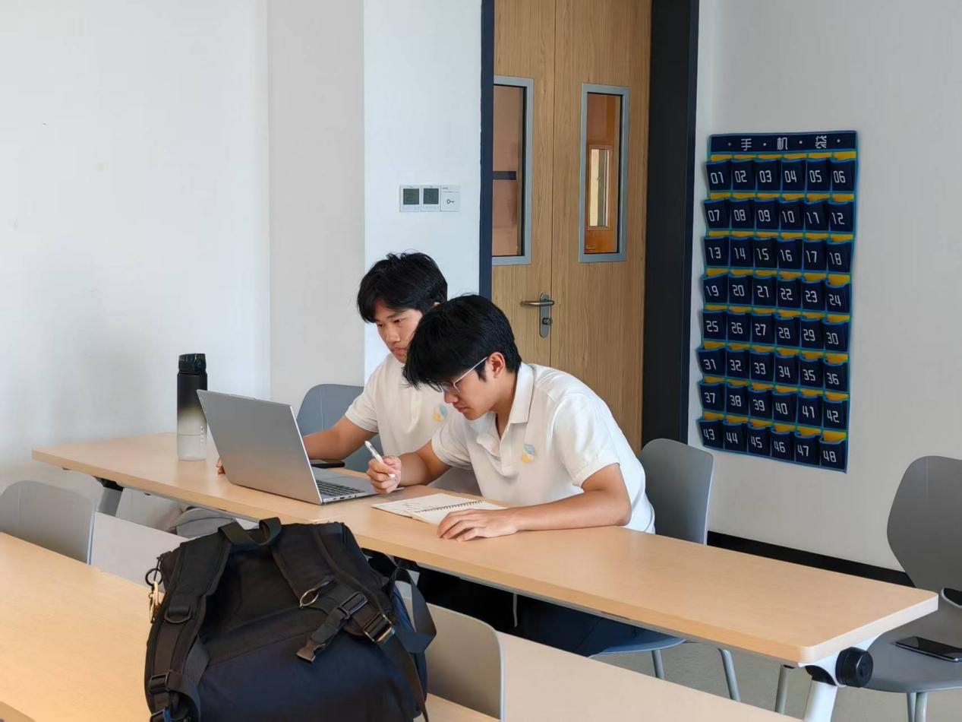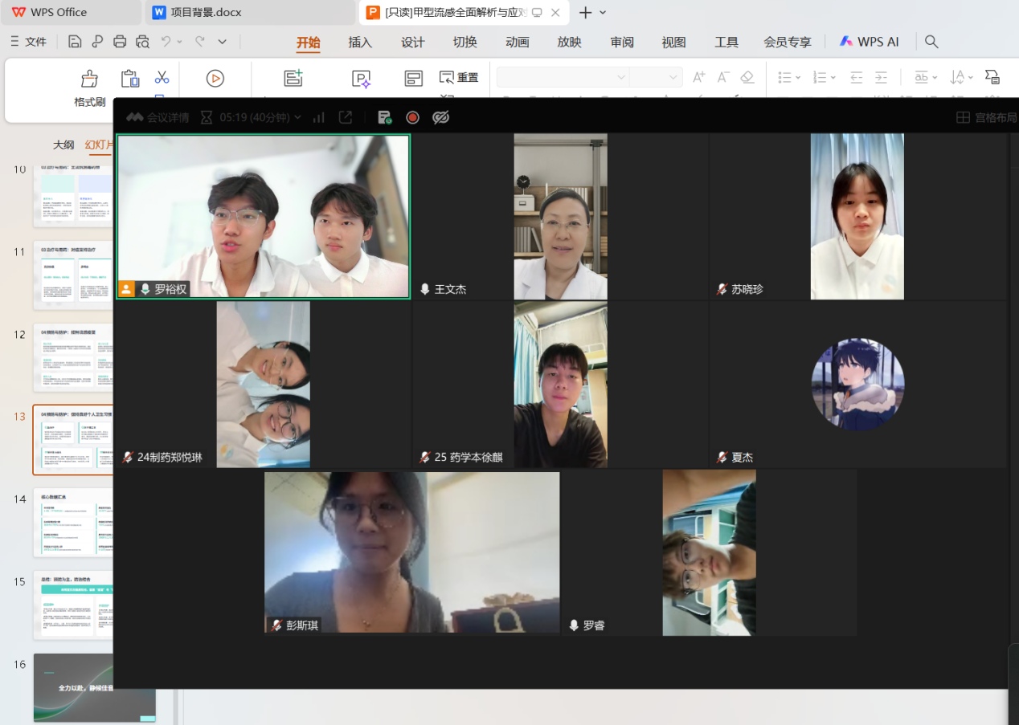

Fu Kai
MD in clinical medicine, Sun Yat-sen University

Diagnosis:
Although the air-monitoring direction was recognized, questions remained about timeliness, virus concentration, cost and the boundaries of expansion.
Plan:
Questions were designed around response speed, the reporter system, yeast survival, device cost, clinical scenarios and future expansion.
Act:
Interviewed Dr. Fu Kai, MD in clinical medicine at Sun Yat-sen University, to obtain advice on clinical feasibility, breath testing and grassroots promotion.
Reflect:
Confirmed that a single-person breath mode is superior, and that response time must be shortened, costs controlled and expansion into lung cancer approached cautiously.

The project had already focused on the conserved HA stalk region, de-emphasized subtype discrimination and begun exploring air monitoring. However, questions such as the yeast sensor's response time, reporter system, cost, yeast lifespan, comparison with existing technologies, whether ambient air or human breath is superior, and whether it could be extended to influenza B or lung cancer still needed to be calibrated.

During the interview, Dr. Fu Kai endorsed the concept of “using an organic organism to detect another organic organism”, which he considered uniquely valuable in synthetic biology. He particularly noted that the breath of people with respiratory or lung infections carries virus particles expelled with aerosols, and that the device would detect such people more effectively. But he also cautioned that the yeast signaling pathway takes about 1–2 hours from receiving a signal to expressing fluorescence; if it takes too long, the device is not timely enough. Airborne virus in ambient air is diluted, and influenza A can survive in air for only a few hours, whereas virus in the human body is more concentrated and easier to detect.

Based on these judgments, Dr. Fu Kai's advice centered on four directions. First, prioritize a single-person breath mode, supported by an enrichment device, with environmental sampling as a supplement. Second, optimize the signaling pathway to shorten response time; fluorescence requires photoelectric conversion and software readout, while blue–white screening can be judged with the naked eye but its expression time is still to be determined. Third, control hardware costs — an active breath device is expected to come down to around 10 yuan, which is what makes grassroots promotion feasible. Fourth, conduct cross-disciplinary interviews with experts in respiratory medicine, biomedical engineering, virus research and other fields, defer lung cancer testing and focus on respiratory viruses such as influenza A; expansion could follow if highly specific breath markers are identified in future. In addition, he reminded us to clarify the yeast's lifespan and replacement plan: activity peaks 2–3 days after revival and can be maintained for 1–2 weeks.

Dr. Fu Kai advised us to focus subsequently on shortening detection response time and controlling hardware cost, and to assess clinical compatibility prudently when expanding the technology. The team thereby understood the possibility of moving from “ambient air monitoring” to “single-person breath testing”. What we had gained: the technical direction was recognized, single-person breath testing is superior to environmental sampling, and low false positives, high sensitivity and ease of operation constitute differentiating advantages. What still needed to be supplemented: the expression time of blue–white screening, the cost of the complete device, long-term yeast survival and replacement plans, quantitative specificity and sensitivity data, a systematic comparison with PCR/test strips, and validation in grassroots applications. This interview advanced the project's clinical feasibility and reminded us that a cutting-edge technology must answer four questions at once: is it accurate, is it fast, is it affordable, and where is it used?
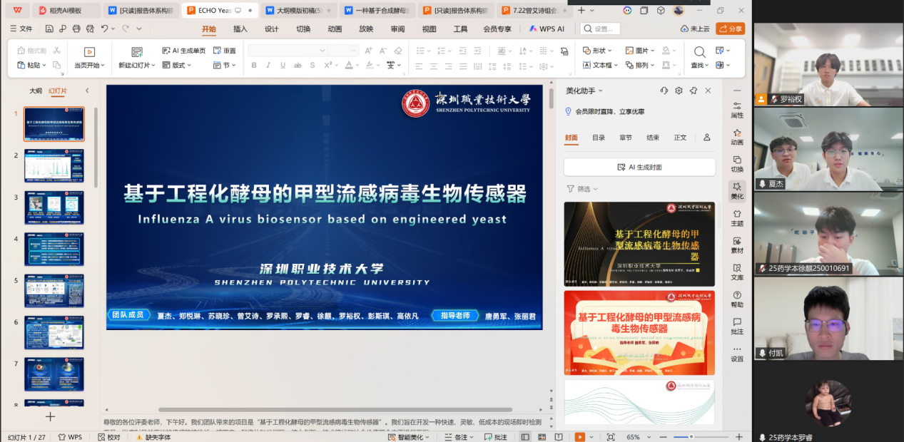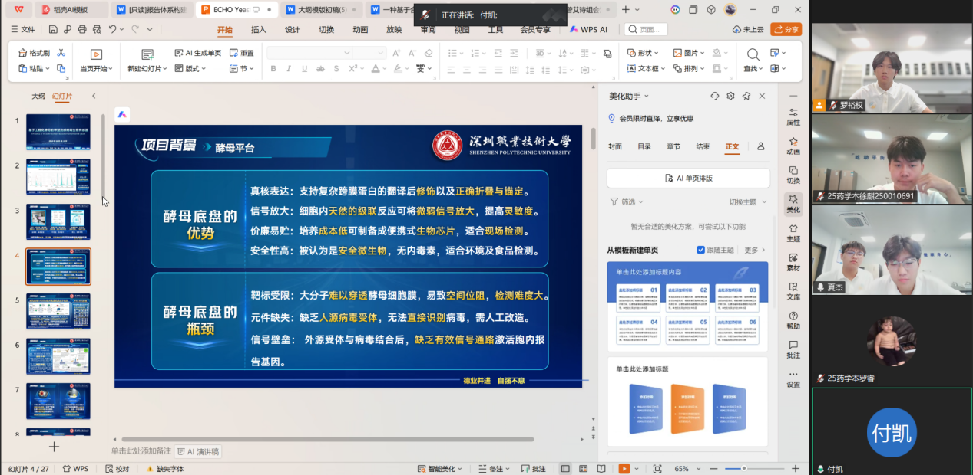

Deng Manqing
Deputy Chief Pharmacist, Department of Pharmacy, a Grade III Class A hospital in Shenzhen

Diagnosis:
The product is positioned as a detection reagent aimed at prevention, but there are still no answers on the practical side: adaptation to susceptible populations, target audience, biosafety, clinical translation and pricing.
Plan:
Interview Deng Manqing, a pediatric clinical expert, to learn about the cooperation of susceptible populations, parents' acceptance, scenario selection, the market pathway and ethical review.
Act:
Present the project and gather Ms. Deng's feedback on the current pediatric situation, the timing of medication, non-pharmaceutical prevention, the technical route, market prospects, special populations and clinical translation.
Reflect:
Through this interview we further confirmed the project's positioning as a detection reagent aimed at prevention, and recognized that the B2B side (institutions such as schools and government public-health programs) should take priority over the B2C side (households and individual users); at the same time, low-load sensitivity, distinguishing live virus from fragments, cost control and compliance review are the keys to whether the project can be implemented.

We had a clear understanding of the application direction of the technology, but that does not equal implementation of the project. We asked a pediatric clinician about several questions we could not answer at the time: children are a high-incidence group for influenza A — can they cooperate with breath testing? What is parents' attitude toward testing and preventive medication? Are settings such as schools and kindergartens really receptive? Is the product a detection reagent or a drug? In the clinical pathway, does it fall under prevention, diagnosis or treatment? What processes must be completed to enter a hospital or a campus? What are the requirements for biosafety and ethical review? Should the target audience prioritize families, schools, medical institutions or the government? What price is competitive?

Ms. Deng endorsed the project's preventive positioning, holding that it is essentially a detection reagent rather than a drug and belongs to the “prevention” stage. If the virus can be identified at a low viral load, that is of great value for early isolation. Physical isolation (masks), frequent hand washing, school closures and influenza vaccines remain the most effective means of prevention. On biosafety, regarding the safety measures the team uses — auxotrophic medium + filter membrane + suicide system — Ms. Deng commented that as long as it is not sprayed into the human body and is used only for environmental/breath testing, the biological hazard is controllable.

On market and implementation, Ms. Deng recommended prioritizing the B2B side: schools are highly receptive, medical institutions are the most receptive, and the government can reduce medical-insurance expenditure; on the B2C side, households depend on price, and the product must benchmark against free vaccines and influenza drugs costing a few tens of yuan. She also suggested making the biological components into replaceable modules to extend to detecting other viruses, bacteria or drug-resistant mycoplasma. Clinical translation requires engaging GCP-certified institutions and hospital equipment departments early, striving to enter clinical guidelines and accumulating real-world epidemiological data; campus promotion must ensure safety and ease of operation, and for susceptible populations in particular there must be “zero operating threshold”.
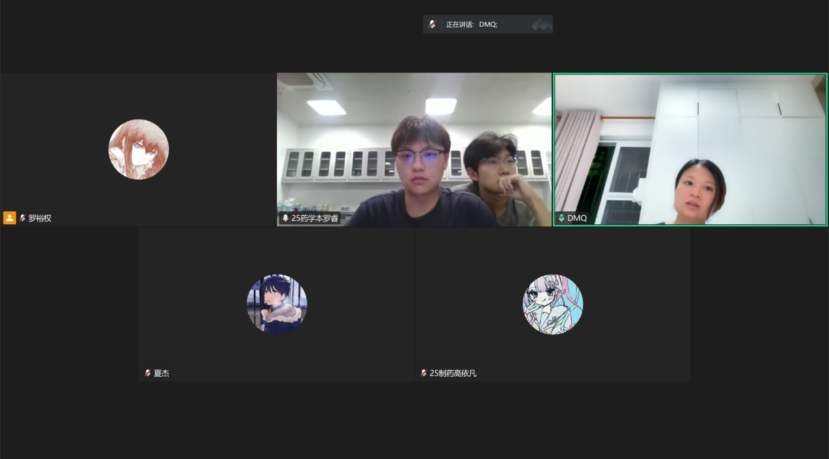
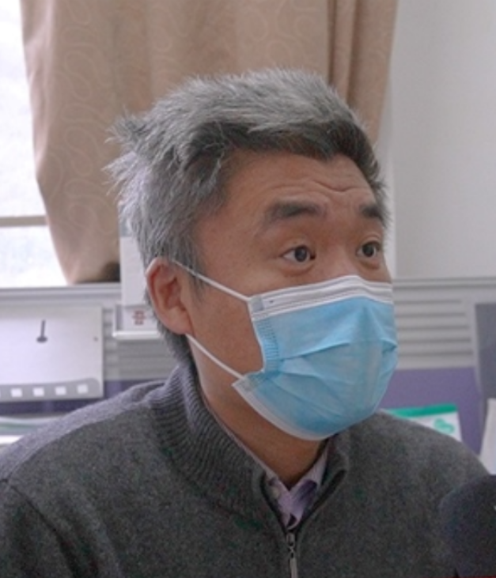
Fang Shisong
Deputy Director of the Pathogen Institute, Shenzhen Center for Disease Control and Prevention

Diagnosis:
The project had settled on a technical route for influenza A detection, but the rigor of the topic selection, the choice of target genes, the bottleneck in air sampling, the registration pathway and the methods of scientific validation remained unanswered.
Plan:
Interview Fang Shisong of the Pathogen Institute of the Shenzhen CDC, consulting on influenza typing, the rigor of the topic, detection technology design, air sampling, implementation and registration, and research methods.
Act:
Present the project and gather the expert's feedback on virus fundamentals, target-gene and antigen design, air collection, registration and translation, the surveillance system, and research for the competition.
Reflect:
We confirmed that testing for influenza A alone carries a risk of missed detection and that dual testing for influenza A and B should be included; target genes should preferentially be conserved regions; air sampling is the bottleneck of the whole chain; registration needs to distinguish research use from clinical use; and research must rely on real samples and statistical validation, while also requiring detailed investigation of influenza A's background and other details.

Although the project's technical route was settled, from the perspective of the CDC and public health we wanted to test the rigor of the topic selection and technical design. Our thinking was to focus on influenza A first, achieve influenza A recognition as a first step, and then consider subsequent expansion. We therefore interviewed the expert Fang Shisong; from the perspective of a government agency for influenza surveillance and laboratory verification, we wanted a CDC expert to review whether the idea of “focusing on influenza A recognition first and expanding step by step” holds up, and to point out regulatory issues in the technical design and later implementation that are easily overlooked.

Fang Shisong began with the rigor of the topic selection, reminding us that testing for influenza A alone carries a risk of missed detection, that the clinical mainstream is dual testing for influenza A and B, and that the project presentation must face up to this shortcoming. On technical design, he recommended using conserved genes such as M/NP/NS for typing, designing primers with reference to sequences from the past 3–5 years and using BLAST to screen conserved fragments of about 200 bp; for antigen expression he preferred the conserved HA neck region, and suggested referring to the mosaic algorithm to cover circulating strains. He also stressed that a new project must be compared side by side with mature methods such as rapid antigen tests and fluorescence PCR across multiple dimensions, not only highlighting its advantages.
Regarding airborne virus detection, the expert affirmed its innovative value and recommended crowded places such as hospital emergency departments, metro stations and schools, but advised against ICUs. He pointed out that the core difficulty lies in air-sample collection: virus particles are small, retention by filter membranes is limited, and collection protocols for bacteria and viruses are not interchangeable, so the choice of collector, wet versus dry collection, and membrane and concentration processes must be studied in depth; if the front end cannot capture the virus, no matter how advanced the back-end detection is, it is useless. On sensitivity, airborne viral loads are generally low, which places extremely high demands on enrichment and detection.
On implementation, the expert distinguished two pathways — research equipment and clinical medical devices: research use requires no stringent registration, but the results have no clinical diagnostic validity; entering a hospital requires a Class III medical device registration certificate from the National Medical Products Administration, at least three clinical trial sites, and performance comparison against mature reagents. On research methodology, he advised obtaining real clinical samples, processing data with statistical methods, analyzing advantages and disadvantages objectively, and communicating more with industry experts rather than following textbooks blindly.

At the end of the interview, the expert and the team agreed on follow-up work: the team would go back and improve the background research on influenza viruses and detection technologies; advance experimental validation with real samples and refine performance metrics and statistical analysis; subsequently engage medical-device industry experts to discuss device design, evaluate the pros and cons of the plan and determine the R&D steps; and stay in contact with the CDC expert whenever questions arose, with the expert also willing to visit the school later to review the project.
From the perspective of public health and the CDC, this interview provided criteria different from those of clinical end users and industrial translation. On topic selection, we must face up to the risk of missed detection when testing only for influenza A and include dual testing for influenza A + B in subsequent planning; technically, prioritizing conserved target genes, choosing the HA neck for antigen expression and referring to the mosaic algorithm gave clear guidance for molecular design; on air sampling, the expert identified front-end capture as the bottleneck of the chain, requiring focused study of collectors, membranes and concentration processes; on implementation, the registration requirements differ between research equipment and clinical medical devices, so the goal must be clarified as early as possible; and in research methodology, real samples, statistical validation, side-by-side comparison and reproducibility became the basic principles for our subsequent experiments and reporting. The expert also said he would be available for contact at any time and was willing to come to the school to review the project, which provided important support for its continued progress.
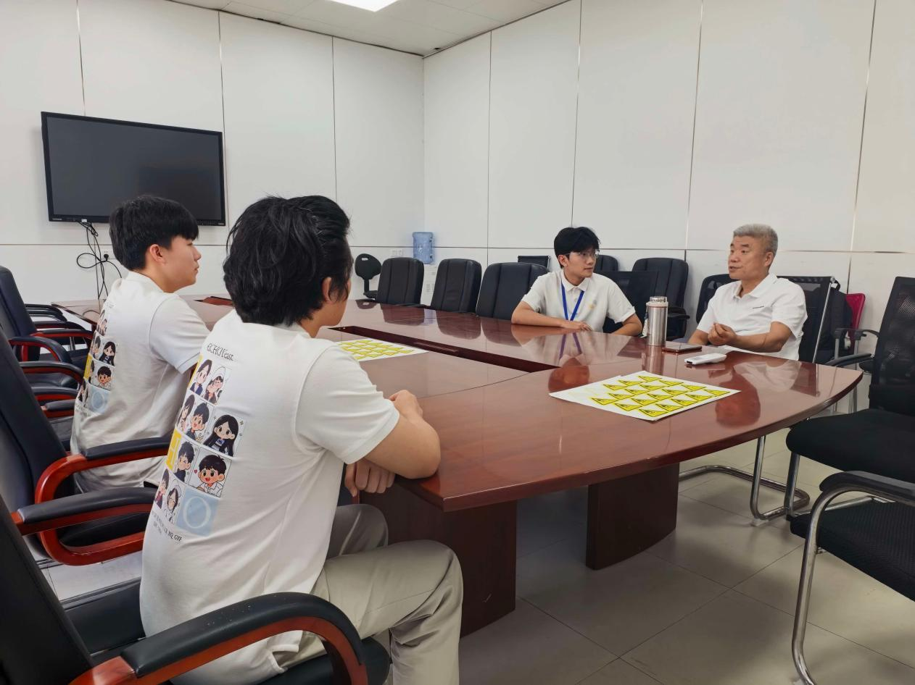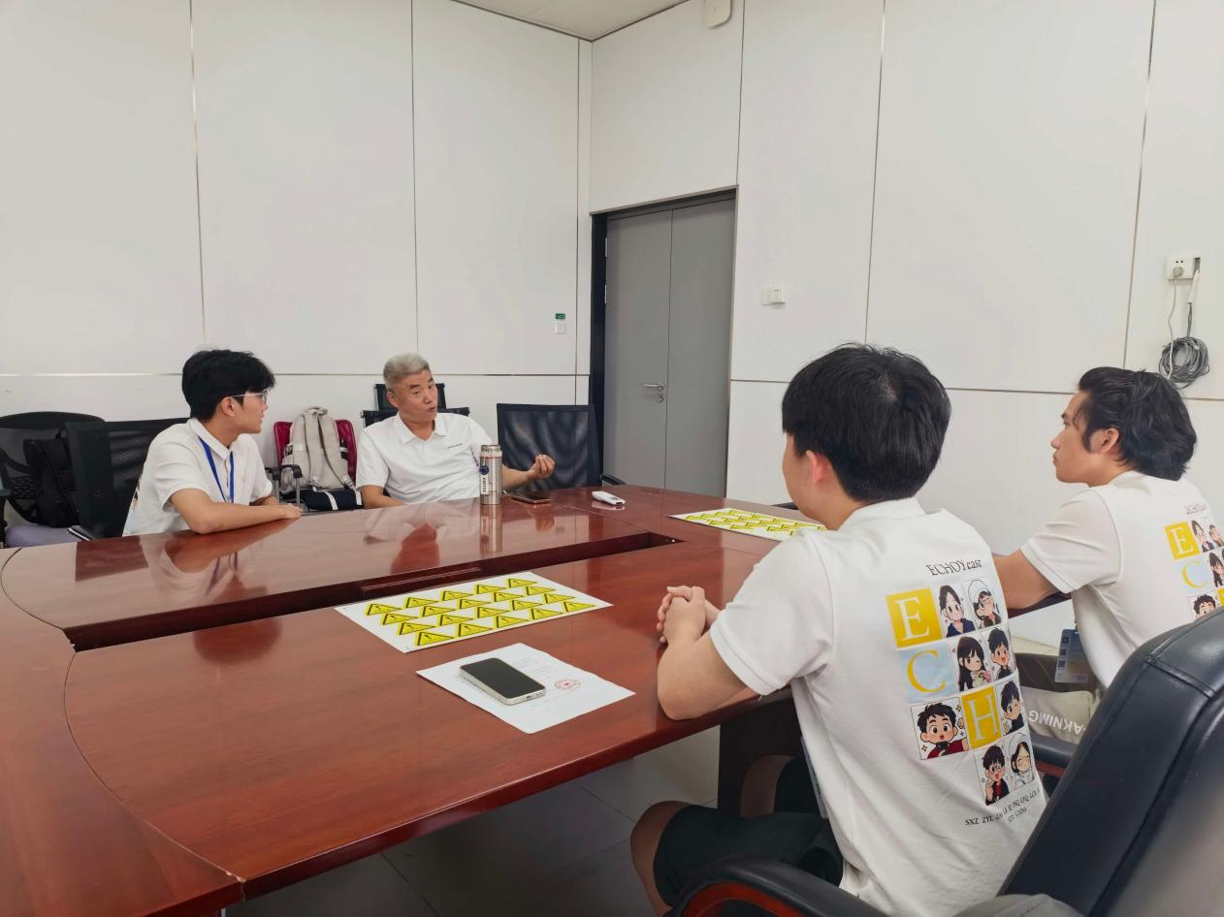
Luo Yiwu
Level-IV Research Officer, Review and Approval Division, Shenzhen Municipal Health Commission

Diagnosis:
The project already had preliminary directions in technical route, testing scenarios and product implementation strategy, but still lacked guidance from the perspective of health-sector administration on industry standards for airborne virus monitoring, product compliance classification, biosafety regulatory requirements and defense strategies for innovation and entrepreneurship competitions.
Plan:
Interview the Health Commission expert Luo Yiwu, consulting on the current state of the industry, scenario selection, experimental validation, biosafety, qualification and compliance, and competition defense.
Act:
After presenting the project, gather the expert's feedback on the current state of airborne virus monitoring, high-value scenarios, product positioning, validation plans, safety design and compliance pathways.
Reflect:
Through this interview we realized that airborne virus monitoring has no mature standards or commercial products, that the project should target risk early warning in enclosed environments rather than taking a clinical diagnostic route, and that biosafety and compliance design are necessary components of the implementation plan.

From the perspective of health-sector administration and policy, we wanted to know whether airborne virus monitoring has a business basis in the existing health system, whether there are official standards, and how the product should be positioned and made compliant. We asked the expert Luo Yiwu to help us judge: does airborne virus monitoring currently meet the conditions for industry application, which category of management should the product fall under, and what regulations must experimental validation and biosafety follow.

Based on his understanding of industry rules, Mr. Luo first noted that the health system does not routinely test for airborne viruses, that there are no official standards or testing methods for airborne virus detection in China, and that such equipment cannot serve as a basis for medical diagnosis — it can only provide general environmental screening and risk early warning, and is not a medical device; existing air sampling mostly relies on laboratory equipment, and there is no commercially mature integrated unit for online virus monitoring. Drawing on his experience in public health management, he stressed that scenarios must not be generalized: open, large spaces have low value, whereas high-value scenarios are fever clinics, elevators, high-speed rail, buses and enclosed classrooms, among which fever clinics have the highest value and can be linked with disinfection equipment to form a management loop; the product could be considered as a supporting sensor accessory for air disinfection machines, with sampling points at both the air inlet and outlet to compare disinfection performance.

On experimental validation, he suggested combining laboratory simulation chambers with on-site testing, using pseudovirus and dyed aerosols to simulate sneezing, varying distance, air speed, temperature and humidity to test detection capability, and establishing a reference threshold for risk concentration to answer “how much detected counts as high risk”, while avoiding false positives such as those caused by influenza B. On biosafety and compliance, he reminded us to add UV-LED ultraviolet disinfection at the air outlet, automatic shutdown and alarm if the membrane ruptures, periodic self-disinfection of the membrane module, and lysis buffer in the collection system to inactivate live virus; since no clinical diagnosis is involved, integrating a disinfection module would classify it as a disinfection device, requiring filing under a disinfection-product license (xiaozihao), and in the absence of a national standard an enterprise standard can be drafted first.

On biosafety and compliance, he reminded us to add UV-LED ultraviolet disinfection at the air outlet, automatic shutdown and alarm if the membrane ruptures, periodic self-disinfection of the membrane module, and lysis buffer in the collection system to inactivate live virus; since no clinical diagnosis is involved, integrating a disinfection module would classify it as a disinfection device, requiring filing under a disinfection-product license (xiaozihao), and in the absence of a national standard an enterprise standard can be drafted first.
For the competition defense, he advised focusing on the detection principle, the scientific logic and the simulated experiment plan, with hardware as a future expansion direction; explaining clearly that the scenario pain point is risk early warning in enclosed environments, not disease diagnosis; and stating the innovation points as general screening and early warning of airborne virus in enclosed environments, linkage with air disinfection equipment, and future expansion to multi-virus detection.

This interview helped us draw clear boundaries: we only provide risk early warning for enclosed environments and do not make human diagnostic devices; we target core scenarios such as fever clinics, elevators, high-speed rail and enclosed classrooms; we focus on the route of sensor accessories for air disinfection machines; we design two validation schemes — laboratory simulation and on-site testing — establish a risk concentration threshold, and write biosafety and compliance design into the project materials and defense slides.
Qiu Xinyuan
Our team uses the yeast Saccharomyces cerevisiae (S. cerevisiae) as the chassis and builds an airborne influenza A biosensor based on the PAGERs system; we have completed the construction of some genetic elements, but have repeatedly hit bottlenecks in experimental design, chassis engineering and iGEM judging strategy. We therefore invited Qiu Xinyuan to guide our current experimental plan and our iGEM work. The expert pointed out the problems in our project, clarified the key validations currently missing, and offered valuable advice.

Chassis and route: validate the premise first, then talk about simplification

The expert raised a key question that we had long overlooked: “Can an intact virus pass through the cell wall and reach the cell membrane?” He pointed out that this is the physical premise for whether the device can work: the yeast cell wall is thick, and there is currently no evidence that intact virus particles can penetrate the cell wall and bind the antibodies on hM1Dq; if validation fails, we should resolutely change the chassis (for example, to Xenopus oocytes) rather than continue investing in complex modifications. Based on this judgment, the expert's core advice was “the simpler the better”: we had previously been stuck on issues such as knocking out endogenous interfering genes and validating the gating system, whereas the expert preferred modifying the yeast's own RTK (receptor tyrosine kinase) system, replacing only the extracellular domain with an influenza A surface antibody protein, and verifying downstream phosphorylation by Western blot. On the reporter system, he offered two routes: adjust the number of PREs or switch to a weaker promoter to reduce leakage; at the same time, molecular-level evidence must be added, using a Western blot of MAPK phosphorylation to prove signal activation rather than relying only on indirect judgment from growth phenotype. The expert also stressed that “strong antigen–antibody specificity” does not equal “high detection sensitivity”: sensitivity must be defined as the number of detectable virus particles per unit volume, and our team precisely lacks the quantitative basis for “the minimum detectable number of particles per unit volume”. For serial knockout of multiple genes, he suggested switching to Golden Gate cloning for plasmid construction to improve the success rate of cloning short sgRNA fragments.

Modeling: use it smartly, not exhaustively

We had hesitated over whether to build a full-chain ODE (ordinary differential equation) model from antigen to GFP, even though most parameters could only be obtained by fitting. The expert considered it acceptable in review to approximate a multi-step reaction with a single Hill function, but the parameters must come from experimental fitting or literature citations and must never be set arbitrarily; the derivation of that approximation must also be written clearly on the wiki. The real value of a model lies in first validating it by matching curves to experimental data, and then using parameter sensitivity analysis to trace back the most sensitive steps in order to guide experiments. Regarding our treating PAGERs as a cascade of “antigen recognition → release of MT1 inhibition → GPCR activation” and trying to encapsulate it with a three-state gate, the expert judged that an ODE description of the input–output relationship and dynamic response is more appropriate than three-state gate logic; mature algorithms already exist for sgRNA, so there is no need to spend effort on over-engineered forms such as Fourier transforms. The expert particularly reminded us that reviewers care about whether the model solves experimental problems, not whether the formalism is fancy; rather than stacking modules, it is better to make the model capable of predicting the whole “response–recovery” process.

HP and the competition: necessity first, and the loop must be real

The expert pointed out that we must think about the “why” and build a complete project background and rationale. He also mentioned that expert statements and outreach cannot replace factual evidence and that “appeals to authority” should be avoided; we should use epidemiological and literature data to demonstrate the value of “airborne transmission detection” and the irreplaceability of the “yeast chassis”. Human Practices is not about quantity or formality; it focuses more on whether the practice actually influenced the project and drove improvement — for example, interview feedback at the hardware level must be translated into design improvements and be validated. The expert's strategy for moving forward was clear: the immediate priority is to produce a functional receptor that can recognize influenza A antigen and to complete the first “simple and clear” DBTL (Design-Build-Test-Learn) cycle before iterating; he also suggested studying the judging handbook and contributing to the community by submitting new parts or education projects.

Three shifts brought about by the interview

(1) Necessity first: the epidemiological basis for airborne transmission detection, the irreplaceability of the yeast chassis and the differentiating advantages over existing technologies are all essentially questions of “why the project exists”, and none of them currently has supporting data.
(2) Review and reflection: we had focused our energy on humanizing the GPCR while neglecting the premise of “whether the virus can pass through the cell wall”; simplified routes such as RTK that “change only the extracellular domain” deserve repeated self-scrutiny in subsequent decisions.
(3) Data are the only language of argument: the background cannot stop at verbal endorsement by experts, model parameters cannot be set by experience, and sensitivity must have quantitative metrics. The expert also affirmed the value of the innovative idea of transplanting PAGERs into yeast.

After the interview, we raised project background research and chassis/receptor feasibility validation to the highest priority, and on that basis continue to iterate and optimize the project.
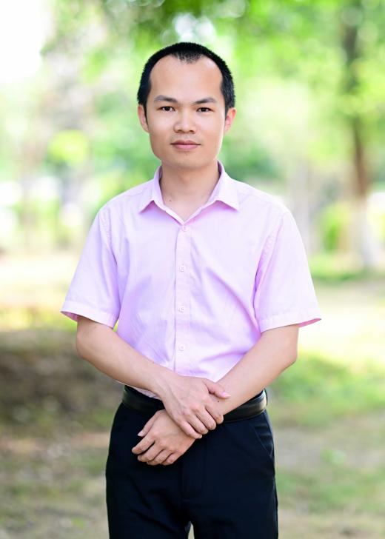
Luo Zhouqing
Professor, School of Life Sciences, Xiamen University

Diagnosis:
The project encountered bottlenecks in yeast sensor experiments, including difficulty in Western blot characterization of membrane proteins, uncertain membrane localization of the human GPCR, plasmid fluctuation in the reporter system, and doubts about cell-wall penetration.
Plan:
Interview Luo Zhouqing of Xiamen University, consulting on membrane protein detection, receptor routes, the reporter system, cell-wall permeability, signal amplification and responses to viral mutation.
Act:
Report the project's progress and problems, and gather Prof. Luo's feedback on experimental procedures, receptor modification, the reporter system, application scenarios and directions for iteration.
Reflect:
Confirmed that the yeast endogenous Ste2 receptor should be modified first, with short antigen epitope peptides used to get the system running; that the reporter system should be changed to genomic integration; that intercellular communication-based signal amplification should be introduced; and that conserved epitopes should be targeted with multiple parallel targets to cope with mutation.

Our project encountered considerable resistance in Western blot characterization of membrane proteins, membrane localization of protein expression, reporter-system stability and the cell-wall barrier — in particular, membrane protein detection produced many non-specific bands and the internal control would not run, and it was uncertain whether the human GPCR could fold and localize correctly in yeast. We hoped to draw on Prof. Luo's experience in yeast engineering to identify the root causes and clarify the direction for optimization.

Drawing on his own experience in yeast membrane protein research, Prof. Luo first helped us sort out the problems with Western blot characterization and the receptor route. Membrane proteins cannot be boiled at high temperature in the usual way; he suggested gentle heating at 50–70 °C for a short time, preferentially extracting proteins by mechanical disruption, using dedicated membrane-protein solubilization reagents, and introducing an HA tag to improve detection specificity and sensitivity. On the receptor, he considered that the human GPCR is affected by glycosylation differences and carries high functional uncertainty, and preferred modifying the yeast endogenous Ste2 (α-factor receptor), designing the protein structure so that it recognizes the target antigen; the signal peptide could also be replaced with a yeast surface-display signal peptide to improve membrane localization.

On the cell wall and the reporter system, Prof. Luo did not recommend the protoplast approach, because the cells are fragile and the procedure is cumbersome, which would lose the core advantage of a yeast sensor; a yeast mutant defective in cell-wall synthesis could be used instead. He also pointed out that the HA protein is only 30–40 kDa, so penetration is not the main obstacle, and short antigen epitope peptides can be used directly in early validation to get the system running first. On the reporter system, he suggested changing from a plasmid-based format to genomic integration to eliminate copy-number fluctuation; mature modification approaches for MEL1 leakage have already been reported in the literature and can be found and referenced, so there is no need to build a library blindly.
On application scenarios and subsequent iteration, Prof. Luo stressed the need to articulate the unique advantages over PCR and colloidal gold, and to clarify the positioning of “direct sensing of intact virus, portable detection”. Airborne virus concentrations are low, and if only a small amount of yeast is activated it is hard to detect, so he suggested using the yeast α-factor native cell-communication pathway to build an intercellular communication + positive feedback signal amplification system. To address viral mutation, he recommended a multi-target parallel strategy: load recognition elements for influenza A, influenza B and different mutant strains into the same chassis, preferentially recognizing conserved antigen epitopes and avoiding high-frequency mutation epitopes.

This interview gave the team clear adjustments in both experimental route and project positioning. Experimentally, we will move to modifying the yeast endogenous Ste2 receptor, using short antigen epitope peptides to get the system running first; the reporter system is planned for genomic integration; we will investigate intercellular communication plus positive-feedback signal amplification; and membrane protein detection will switch to gentle heating and mechanical disruption, with the HA tag evaluated. In the literature, we will consult iScience methods for membrane protein Western blotting, Cell papers on yeast GPCR modification, yeast surface-display signal peptides, cell-wall-defective mutant strains, and MEL1 leakage modifications. On project materials, the HP team will compile the materials and send them to Prof. Luo for review, sort out the reporting logic, and distill the unique advantages of this technology compared with existing detection methods.

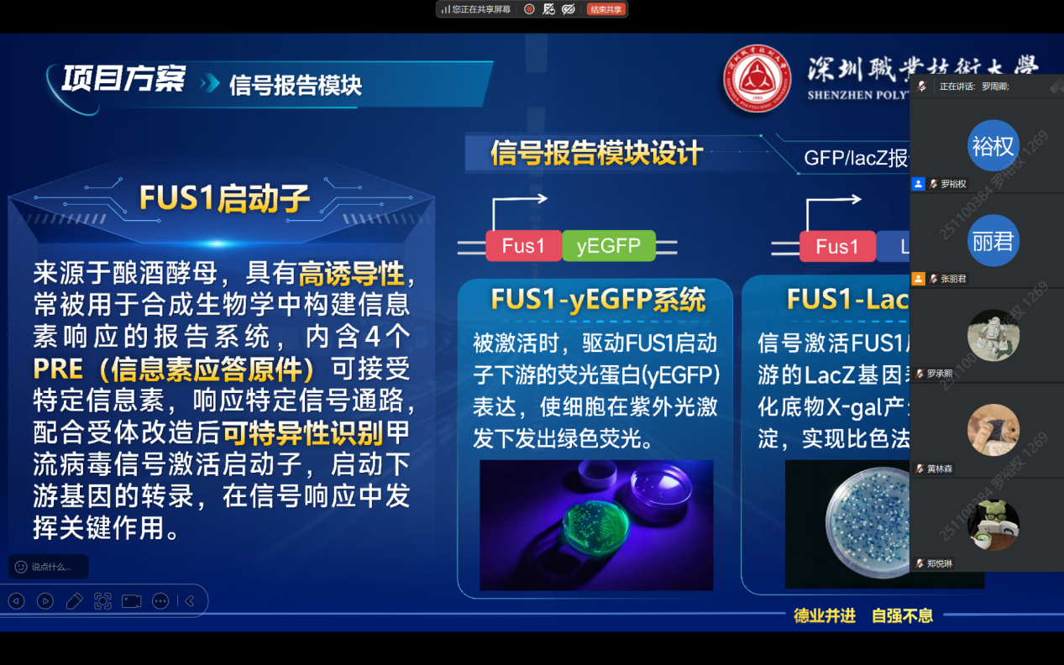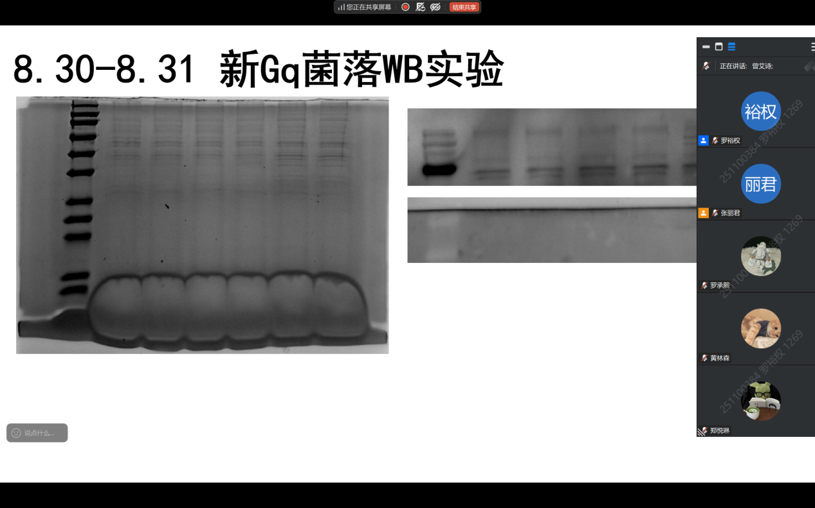
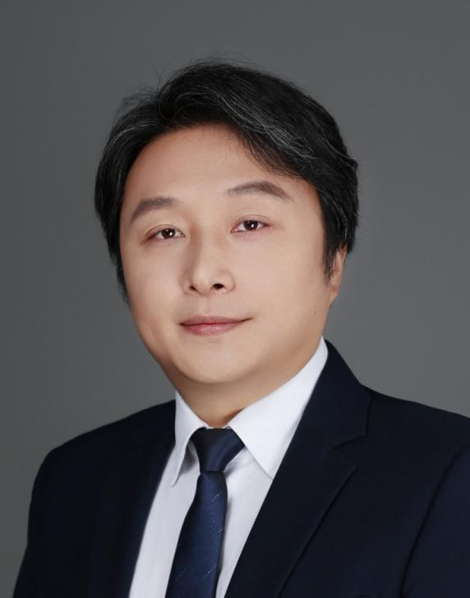
Wu Hui
Professor, Dalian University of Technology

Diagnosis:
The project hit bottlenecks in all three modules — signal recognition, transduction and response: Western blot characterization was unsatisfactory, membrane protein expression was uncertain, and reporter-system leakage was serious; problems existed at every node.
Plan:
Interview Wu Hui of Dalian University of Technology, consulting on experimental progress, membrane protein expression, reporter-system leakage, CRISPR knockout and iGEM strategy.
Act:
Report the project's overall concept and the progress of each module, and gather Prof. Wu's feedback on experimental optimization, getting the pathway to work, part submission and detection formats.
Reflect:
Confirmed that we should first get one complete pathway working and achieve a visual response before optimizing components; that membrane protein expression should repeat literature conditions; and that reporter-system leakage could be addressed by adding a repressor or switching promoters.

As the project advanced, each module ran into resistance: Western blot detection of membrane proteins gave unsatisfactory bands, the humanized receptor expressed poorly in yeast, the MEL1 reporter system leaked seriously, and CRISPR knockout efficiency was unstable. We hoped that Prof. Wu's guidance would help us identify the root causes and clarify what should be prioritized at this stage.

Prof. Wu first affirmed that the project idea is novel and that using living cells to detect viruses has application potential. But he also pointed out directly that, from signal recognition to transduction to response, every node currently has problems and uncertainty is high; he suggested first repeating conditions that have already worked in the literature rather than innovating on every component ourselves. He stressed that the immediate priority is to get one complete pathway working and achieve a visual response before considering replacing components to improve sensitivity and speed; only after a complete story is in place is there room for optimization.
For specific experimental problems, Prof. Wu gave advice based on his experience. Membrane protein expression is inherently very difficult, and cross-species expression is even harder; he suggested first referring to conditions in the literature that achieve active expression. On Western blot, he noted that yeast cell disruption cannot rely on snailase alone and recommended liquid-nitrogen grinding; a low protein amount on SDS-PAGE is very likely an extraction problem. On reporter-system leakage, the FUS1 promoter already has background expression without α-factor, so one can try adding a repressor or screening other, more stringent promoters. On CRISPR knockout, he suggested designing several targets and doing them in parallel to save time on repeated attempts. Regarding iGEM part submission, he encouraged submitting as long as there is a slight trend — a signal-detection element with preliminary effects is enough.
On application scenarios and detection formats, Prof. Wu suggested comparing against RT-PCR for environmental sampling and finding differences in time cost and sensitivity; freeze-dried yeast powder could serve as the basis of a detection reagent, and serial dilution should be performed during testing to establish a standard curve. He also mentioned that detection speed matters: RT-PCR takes about a day, whereas yeast culture may take two to three days, so we need to think about how to shorten the response time.

This interview led the team to readjust its priorities: instead of pursuing perfection in all modules at once, get one complete pathway working and achieve a visual response; experimentally, switch to liquid-nitrogen grinding for cell disruption, optimize membrane protein extraction, try adding a repressor to the reporter system or switching promoters, and run CRISPR with multiple targets in parallel; at the same time, compile elements with preliminary trends for iGEM submission and design a standard-curve experiment to evaluate the freeze-dried powder detection format. Prof. Wu also affirmed the novelty of the project and encouraged us to build a complete story first and then progressively replace components to improve performance.

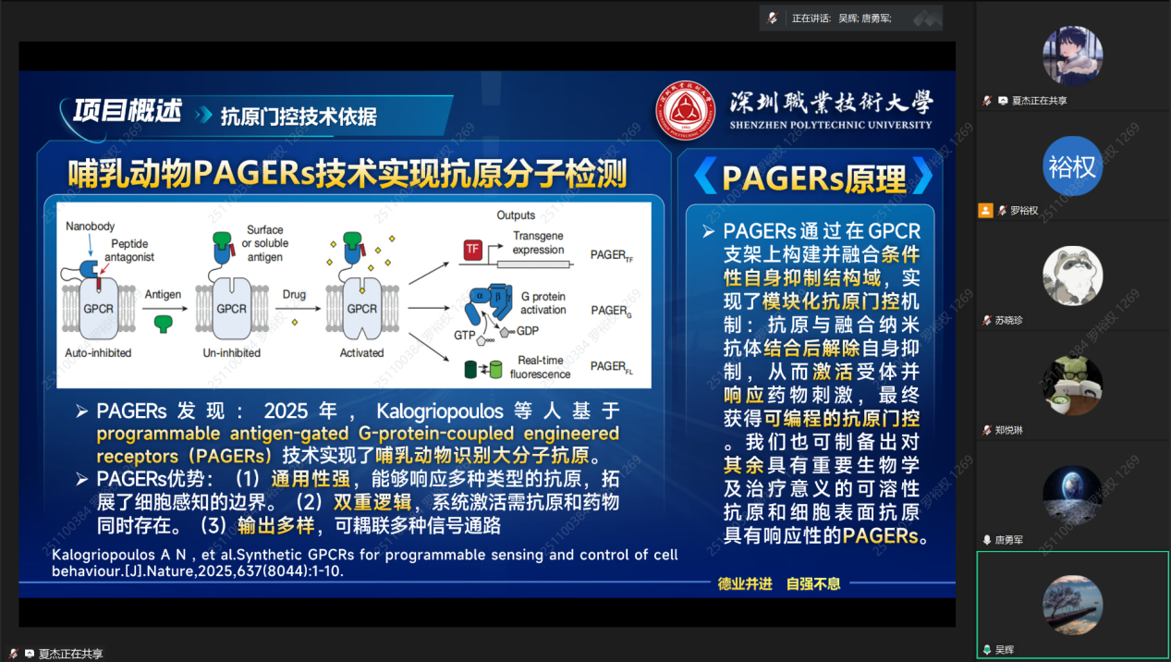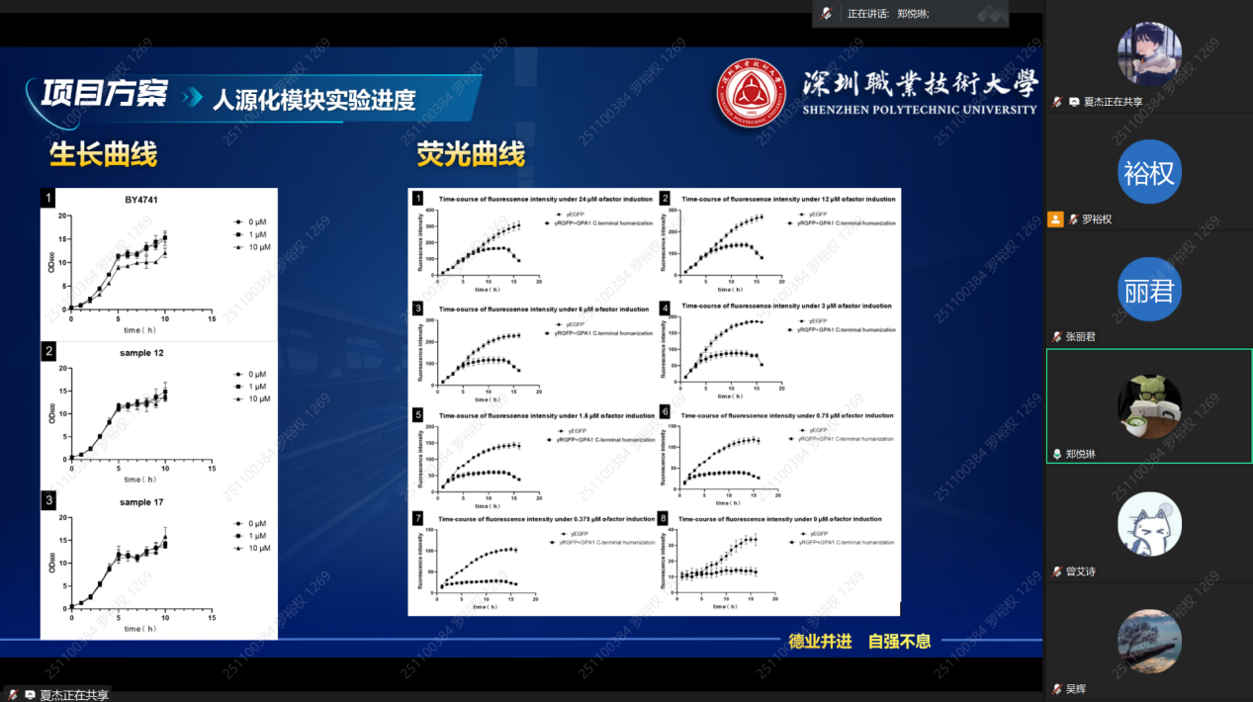

Jia Honghua
Research Fellow, College of Life Science and Pharmaceutical Engineering, Nanjing Tech University

Diagnosis:
The project encountered resistance in protein expression, membrane localization, Western blot characterization and reporter-system leakage; the modules were not yet fully working, and we also needed to clarify how our work differs from existing work.
Plan:
Interview Jia Honghua of Nanjing Tech University to examine the project design, performance metrics and validation methods from a synthetic-biology and engineering perspective.
Act:
Report the project concept and the progress of each module, and gather Prof. Jia's feedback on literature comparison, membrane protein validation, the reporter system, chassis choice and iGEM strategy.
Reflect:
Confirmed that we should focus on final outcomes such as sensitivity and limit of detection, use fluorescent fusion to verify membrane localization, and refer to existing yeast surface-display work to clarify our novelty.

As the project has progressed, construction is complete, but functional expression and validation are still not fully working. We asked Prof. Jia, from the perspective of synthetic-biology engineering, to help us judge the core problems in the current design and what should be validated first next.

Prof. Jia said that his own research area is not yeast, but after listening to the whole presentation he found the project idea interesting, although the workload is considerable and some steps are not yet fully working. He particularly mentioned a paper published in ACS Synthetic Biology in September 2024 by Wei Na's team at the University of Illinois, which also used a yeast biosensor to detect H1N1, displaying a signal protein on the yeast surface — a relatively simple and effective approach. He suggested the team consult that paper, compare the differences between surface display and membrane-anchored approaches, and clarify our own novelty. He stressed that iGEM values both innovation and final outcomes; a biosensor ultimately comes down to two key metrics — sensitivity and limit of detection/linearity. Results are what matter most.
Regarding the uncertain membrane protein expression and localization, he suggested fusing a fluorescent protein to the tail of the membrane component, first verifying whether it successfully reaches the membrane and then using confocal microscopy to observe the fluorescence localization; if membrane expression is difficult, consider whether surface display might be more sensitive than full membrane anchoring. On the cell wall, Tang mentioned using co-incubation with a low concentration of lytic enzyme to hydrolyze some glycosidic bonds and enlarge the pore size in order to detect bacteria; Prof. Jia considered this approach usable for virus detection and thought it a very good combination of ideas.
On reporter-system leakage, Prof. Jia considered that the problem is not necessarily only in the promoter — cascade regulation is complex; switching to a weak promoter or knocking out the chassis are both worth trying, but they are difficult and he had no particularly good suggestion. The recognition element has little to do with the chassis; the key is whether it can be expressed correctly. Regarding iGEM judging, he considered that the final result depends on the judges and that student performance also matters a great deal, and he recommended that Liu Guangna (who has led teams to multiple gold medals) and Liu Wanlong (who has worked with yeast and can advise on iGEM) talk with the team.

This interview moved the team from “burying ourselves in complex design” to “validate first, then optimize, and look at results”. We plan to consult the 2024 ACS Synthetic Biology paper and compare surface display with membrane-anchored approaches; use fluorescent protein fusion to verify whether the membrane protein successfully reaches the membrane and locate it by confocal microscopy; evaluate the feasibility of treating the cell wall with lytic enzyme; continue trying solutions to reporter-system leakage; and sort out outcome metrics such as sensitivity, limit of detection and linearity, while contacting Liu Guangna and Liu Wanlong for advice on iGEM and yeast experience. Prof. Jia also affirmed the ingenuity of the project idea and the team's efforts, reminding us that we must ultimately deliver demonstrable results.

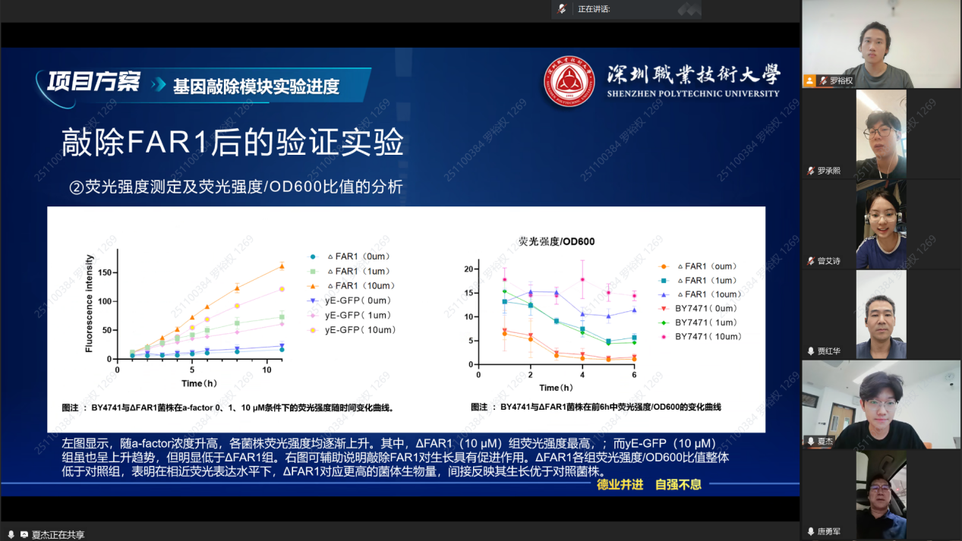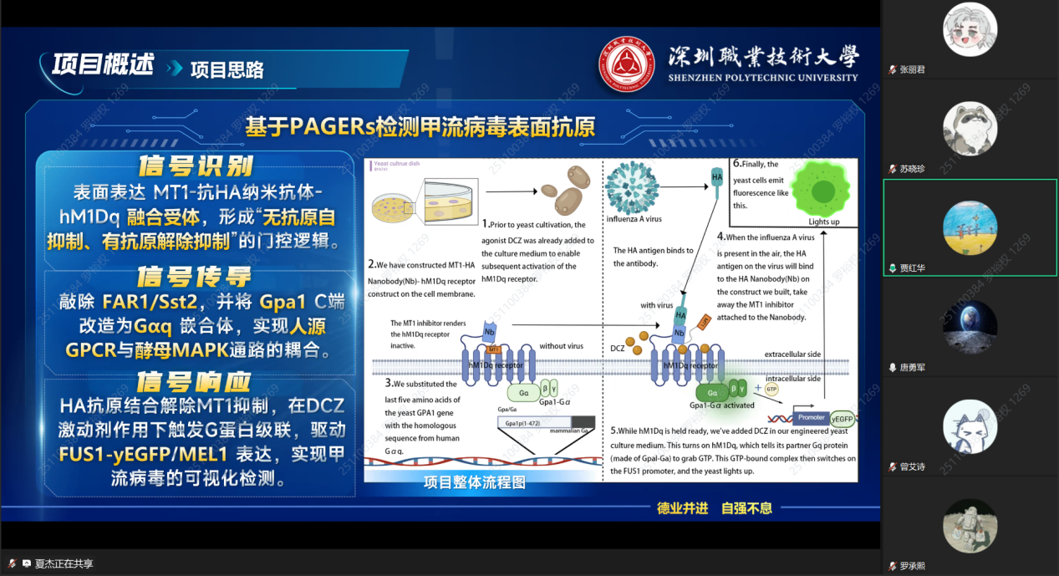

Zhang Haili
PhD, Academy of Mathematics and Systems Science, Chinese Academy of Sciences
Diagnosis:
The project's wet-lab work has produced some data, but the modeling direction is still unclear: ODE, air diffusion and promoter screening are running in parallel with no priority; the existing growth curves and fluorescence time-series data show differences visible to the eye but lack quantitative statistical support.
Plan:
Interview Zhang Haili of the mathematics teaching and research group at Shenzhen Polytechnic University, consulting on possible modeling modules, statistical methods for the data, two-way validation between modeling and experiments, and practical constraints.
Act:
Present the project rationale, the modular experimental strategy and four potential modeling directions, and gather Ms. Zhang's feedback on the feasibility, priority and implementation path of each direction.
Reflect:
Confirmed that priority should go to fluorescence time-series prediction and statistical hypothesis testing based on existing data, with ODE as a fallback and the air diffusion model deferred; modeling must serve the wet lab and avoid over-complexity.

The project already has some experimental data from the humanization modification and the signaling reporter, including OD time series and fluorescence time series under an α-factor gradient, but the team is not clear how to distill content that can support the iGEM modeling section from these data. We also listed several directions — ODE, air enrichment, promoter screening, the signaling pathway — but time is tight and we needed an expert to help us judge which are worth doing and which can be deferred.

Ms. Zhang evaluated the four modeling directions the team had laid out one by one and gave clear priority judgments. She considered that the ODE model depends on complete experimental data, that the current data are insufficient and implementation would be rather difficult; that the air diffusion model is hard to validate with this project's wet-lab experiments, is weakly coupled to the project and therefore ranks last; and that the promoter screening model can be referenced but is not the most urgent direction at present.
Her strongest recommendation was statistical analysis and time-series prediction based on the existing OD–fluorescence time-series data. On one hand, hypothesis testing can be used to calculate P-values, providing quantitative evidence for experimental differences visible to the eye; on the other hand, the first and second derivatives of the fluorescence and OD time-series curves can be used to predict later trends from early data alone, shortening detection time and moving toward real-time detection. She pointed out that this direction can feed back into experiments and aligns with the orientation of iGEM modeling scoring. On the humanization modification, she considered that it can currently only be assessed indirectly through growth curves and that statistical testing could be introduced; an experiment to measure G-protein binding efficiency directly and completely has not yet been done.
Taking into account the project's current time and data conditions, Ms. Zhang also reminded us that successful data have not yet been obtained for some modules in the wet lab and that modeling depends heavily on measured data; that time is tight, so it is inadvisable to open up several complex modeling efforts at once; that modeling need not pursue over-complexity; and that the core of modeling is to serve experiments and solve practical problems, not to be formally sophisticated.

This interview helped the team clarify its modeling priorities: the highest priority is derivative-based time-series prediction using the existing OD–fluorescence time-series data, exploring the feasibility of predicting later results from early data alone and shortening detection time; the second priority is to supplement statistical hypothesis testing for the humanization modification and control experiments and provide P-values; the multi-equation ODE system serves as a fallback, prioritizing reuse of literature parameters and attempting fitting once more data are produced; the air enrichment and virus spatial diffusion models can be deferred if time is tight. The team will continue to collect OD time series and fluorescence time series under the α-factor gradient, and growth-curve data for each group of the humanization modification, retaining biological replicates; complete comparative validation of single-module, dual-module and full-pathway engineered strains; confirm with Zhang Lijun whether P-values for statistical significance need to be output; and, once preliminary time-series prediction results are produced, schedule a second interview with Ms. Zhang Haili to review the statistical methods, model logic and fitting scheme. Ms. Zhang also reminded us that modeling need not pursue sophisticated formalism; being able to serve experiments and solve practical problems is what matters.
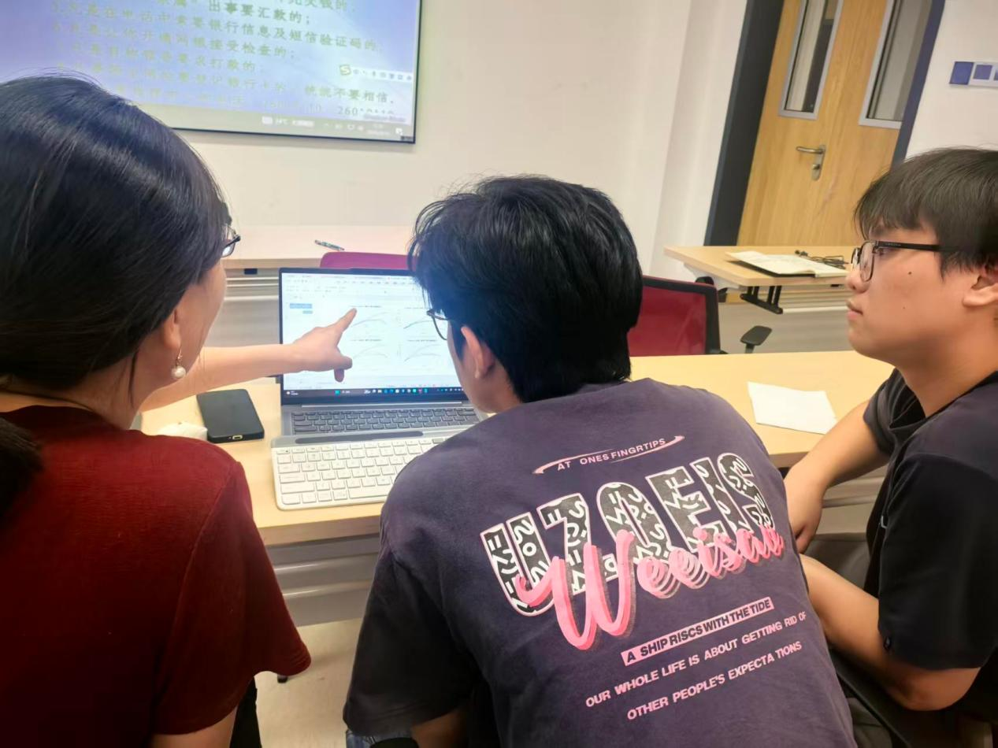
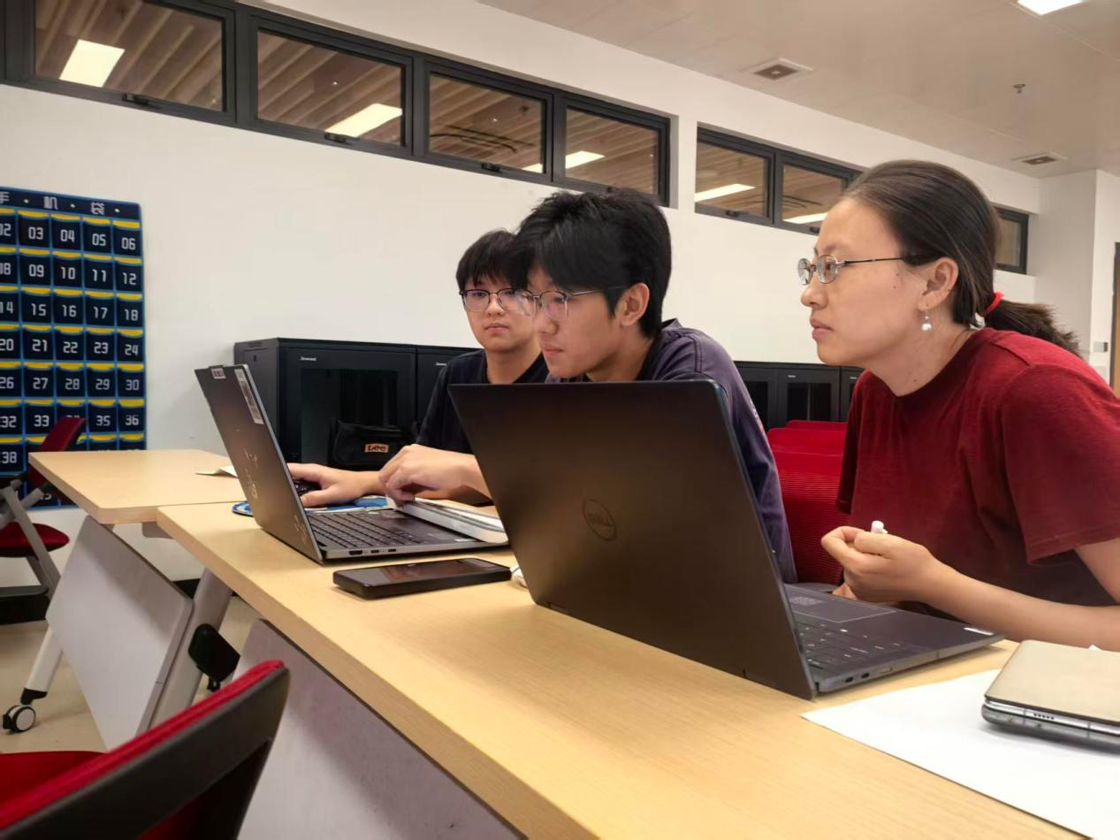
Liu Xiaolong

Diagnosis:
The team has completed structure prediction for 16 nanobodies and obtained H1N1/H2N2/H3N2 HA antigens, and has carried out preliminary docking with an online website, but the applicability of the tools, the quality of the modeling, the structural preprocessing and the depth of the result analysis have not been verified.
Plan:
Interview Liu Xiaolong, consulting on the choice of molecular docking tools, modeling methods, presentation of results and the validation workflow.
Act:
Report the current docking progress and the way results are analyzed, and gather Mr. Liu's feedback on tool algorithms, modeling software, free-energy decomposition, MD simulation and wet-lab validation.
Reflect:
Confirmed that the current methodology has systematic deficiencies: we need to remodel with AlphaFold 3.0, verify the scope of application of the docking tools, add MM/GBSA decomposition and MD simulation, and ultimately close the loop between computation and experiment through SPR/MST.

At the current stage, the team is using molecular docking to provide computational simulation support for the project; we have completed structure prediction for 16 nanobodies and obtained HA antigens of three subtypes, and carried out preliminary docking with an online website. But we are not sure whether these tools are applicable to nanobody–protein systems, nor whether the result analysis is professional enough and able to withstand reviewers' follow-up questions. We therefore asked Mr. Liu to review our methodology and validation workflow.

Mr. Liu first pointed out that the online docking website the team currently uses may not be designed specifically for protein–protein or antibody–antigen docking, and that the scope of application of its algorithm needs to be verified; nanobodies have a special structure, unlike Y-shaped IgGs, so general protein docking algorithms may not apply. He stressed that the fact that a website produces a result does not mean its methodology supports our system: we must read the original literature and confirm whether the sampling algorithm covers protein–protein docking and whether it is applicable to nanobodies.
On modeling and structural preprocessing, homology modeling tools such as Swiss-Model are unreliable when template homology is below 25%, and he suggested switching to AlphaFold 3.0, whose predictions are more accurate and come with confidence scores; after modeling, a Ramachandran plot assessment is needed, requiring more than 95% of residues to fall in allowed regions; HA structures downloaded from the PDB need to have water, metal ions and salt ions removed, and hydrogen atoms added with charge balance.
On result analysis and validation, presenting only the total binding energy is not enough; MM/GBSA free-energy decomposition should be performed, analyzing the contribution of each residue to verify whether the key interactions are concentrated in the CDR region; for visualization, heat maps and PyMOL are recommended to show binding details. Docking results represent only a rigid or semi-flexible state, so molecular dynamics simulation of at least 100 ns must be added to verify the stability of the complex; ultimately, SPR or MST wet-lab experiments should verify the actual affinity, forming a complete loop of “modeling–docking–analysis–MD–wet lab”. As for tools, industrial-grade software such as Rosetta and Boltz is authoritative but has a high deployment threshold; at this stage we can continue using online tools, but must confirm that the algorithm is public, has original literature and is widely cited by peers; PLIP can be used for interaction analysis. AI-assisted computation is acceptable, but the method must come from an open-source, peer-validated path.

This interview made the team realize that molecular docking is not finished once a result is produced — the methodology itself must withstand scrutiny. Subsequently we will use AlphaFold 3.0 to remodel the 16 nanobodies and add Ramachandran plot assessments; preprocess the HA protein by removing ions, adding hydrogen and balancing charges; verify the original literature and scope of application of the existing docking website; perform MM/GBSA free-energy decomposition and produce residue-contribution heat maps; add molecular dynamics simulation to verify the stability of the complex; and ultimately close the loop with SPR/MST wet-lab experiments. In the wiki and the report, we will cite the original literature of the methods used, provide model evaluation data, and state clearly the scope of application of the tools and the reasons for choosing them. In addition, Mr. Liu Xiaolong will continue to guide our mathematical modeling work, helping us continuously improve the connection between modeling ideas and experimental data.
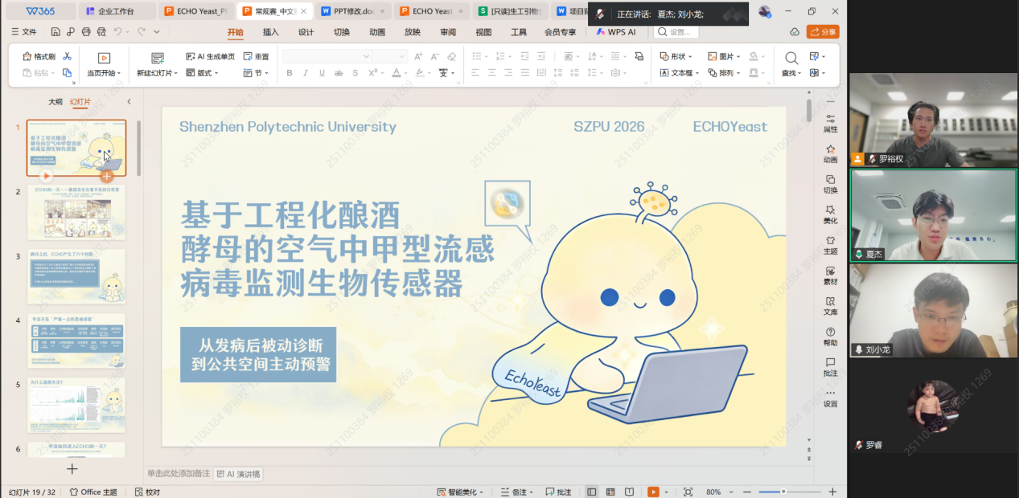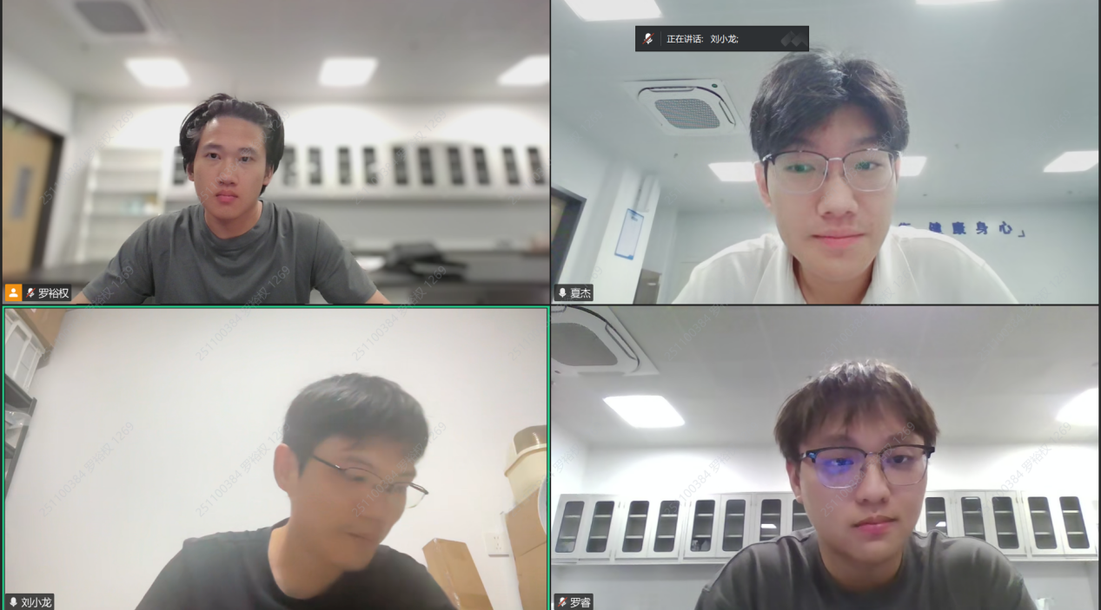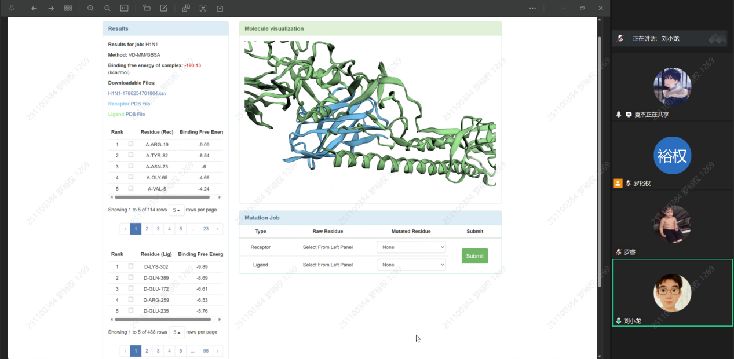
Deng Rongkang
Enrichment bottlenecks and competition delivery strategy from a hardware-engineering perspective

Diagnosis:
The project's device concept is clear, but the core bottleneck of airborne-virus enrichment has not yet been solved, and we lack experience in hardware engineering, R&D processes, component selection and competition delivery strategy.
Plan:
Interview Deng, a medical-device hardware development engineer, consulting on the device plan, enrichment technology, R&D process, intellectual property and competition delivery.
Act:
Report the device concept and working mode, and gather Mr. Deng's feedback on enrichment approaches, R&D processes, competition strategy and industry practice.
Reflect:
Confirmed that airborne-virus enrichment is the greatest difficulty, that during the competition we should prioritize the principle block diagram and a partial demonstration unit rather than pursuing a complete prototype, and that the defense must show a thorough grasp of the principles to avoid being judged as fabricating results.

The project plans to develop a device that can collect influenza A virus from ambient air, enrich it, complete detection and issue a risk warning, targeting enclosed spaces such as schools and cruise ships. But we lack experience in hardware engineering, and in particular are unclear about airborne-virus enrichment, component selection, R&D processes and competition delivery. We therefore asked Mr. Deng, from the perspective of medical-device development, to help us judge what is realistic and what the competition stage should aim for.

Mr. Deng first helped us organize our thinking: the detection chemistry and optics are actually manageable, and the real bottleneck is the capture and liquid-phase enrichment of virus in the air. Virus particles are extremely small, so if air is bubbled directly into the reaction liquid, most of the virus escapes as bubbles and dissolves with difficulty, and after prolonged bubbling the liquid also evaporates. He proposed two approaches: first, vortex agitation, so that air and liquid make full swirling contact; second, membrane filtration, with multiple membrane layers — the upper layer retaining bacteria and the lower nanomembrane retaining viruses, which are then washed off with eluent. The trouble with membrane filtration is that viruses easily pass through the membrane and high pressure causes clogging, which can be alleviated with pulsed pressurization or shaking. He also mentioned that exosome enrichment from urine follows a similar logic: it can be done in the lab, but in engineering it runs into practical problems such as time, clogging and impurities.
On timing, Mr. Deng felt that producing a complete prototype in two or three months is unrealistic. He suggested first producing the appearance drawing, the working-principle block diagram and the module-level schematic diagrams to explain the logic clearly, and also making a partial demonstration unit of the core function rather than a fully connected machine. But he particularly reminded us that the team must thoroughly master the whole plan and must not present drawings while being unable to explain the principles, as that would be treated as fabricating results.
He also laid out a fairly clear line for the R&D process: first write the Product Technical Requirements, setting out clearly everything that can be quantified — sampling duration, air-pump flow rate, liquid volume, temperature and humidity, false-positive/false-negative metrics and validation methods — while checking industry standards and similar devices; then determine the technical route, first building a simple simulation device to verify whether the virus can enter the liquid phase and how efficient the enrichment is, without rushing to build the complete machine; then split hardware and software, with the lower-level controller handling the air pump, solenoid valves and temperature control, and the host computer providing the human–machine interface, defining the communication protocol properly; then build a prototype and iterate through testing to find the balance between performance and cost. Since the device involves live virus, internal inactivation plans and safety validation must also be considered in advance.
On tools and intellectual property, he suggested learning programming in a targeted way around subtasks rather than studying broadly; AI can be used, but key parameters and regulations must be checked against the original sources. On innovation, the vast majority of products are not original from scratch: one can refer to air purification equipment and enrichment devices in published papers, adapting parameters on an existing basis and prioritizing reuse of mature modules. On patents, the situation is relatively relaxed for students, but once commercialized, freedom-to-operate searches and design-arounds are required, and one must not directly copy or disassemble a competitor's product. Regarding yeast recognizing HA protein, he said he had not investigated commercial products of the same kind; fragment-level research might exist in laboratories, but complete devices are rare, and we would need to search the literature ourselves.
Finally, he suggested that we prioritize producing the Product Technical Requirements document, then use it as the basis for the appearance, structure and principle block diagrams as competition materials; drawing and refining the plan can be discussed further later.

This interview made the team realize that the main difficulty in building a complete device lies in airborne-virus enrichment. Subsequently we will prioritize completing the Product Technical Requirements document, clarifying the required specifications of the device we are building; based on the technical requirements, draw the appearance drawing, the working-principle block diagram and the module-level schematic diagrams as competition materials; and at the same time produce a partial demonstration unit of the core function. On component selection, we will prioritize reusing mature submodules, referring to air purification equipment and published enrichment devices and making adaptive adjustments rather than developing everything ourselves; on patents, we will carry out freedom-to-operate searches and design-arounds. For defense preparation, team members will thoroughly master the logic of the whole plan to ensure they can answer the judges' questions. Mr. Deng also said that further drawing and plan refinement can be discussed and coordinated later, providing continuing support for the project's hardware progress.
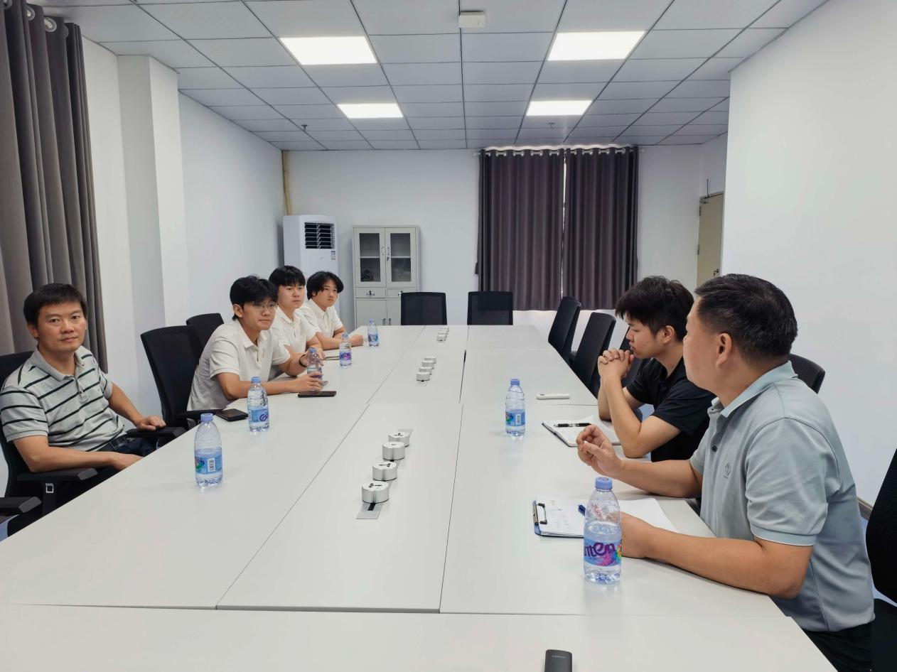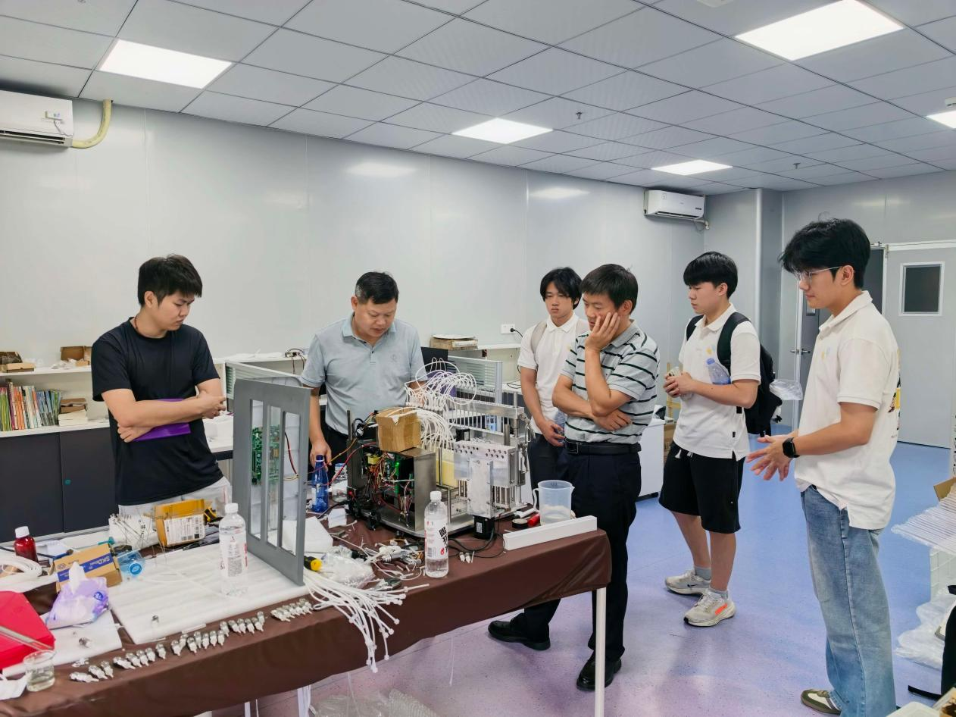

Academic exchange
As the project advanced, we not only obtained guidance from experts in clinical practice, disease control, industry and modeling through interviews, but also actively exchanged ideas with other iGEM teams. From the South China iGEM team meetup, to the Asia-Pacific iGEM team conference (APiC), and to the online yeast workshop co-organized with several universities, we shared our project, discussed difficulties and learned from experience, continuously calibrating our direction through peer feedback. These exchanges not only showed us the highlights of other teams, but also helped us face our own shortcomings; while discussing each other's project difficulties, we also gained a great deal of inspiration from other teams.

Summary of the South China iGEM meetup
At this South China iGEM meetup, the team had face-to-face exchanges with several iGEM teams from South China and gained a great deal from project sharing, academic discussion and mock review.
At the meetup, teams from different places could share their projects. Our team presented the influenza A air-detection project on the big screen, explaining the overall design logic from the yeast chassis and signal recognition to the reporter system. Other teams raised questions about low airborne virus concentrations, yeast sensitivity, reporter-system leakage and the differences from traditional detection methods. The mock review session that followed let us experience the pace of an iGEM defense in advance; some of our answers were not polished enough, but precisely for that reason they exposed the weak points in our project presentation. We recorded these questions and pieces of feedback one by one and, after the meeting, compiled them into a list for subsequent improvement. Looking at the questions collected, they mainly fell into four categories: at the experimental level, yeast response time, signaling pathway validation and virus concentration thresholds; at the mechanical and cost level, model calculations, cost control and yeast replacement; at the application-scenario level, where the device would be installed, data coverage in large scenarios and the feasibility of home self-testing; and other aspects such as the advantages over existing detection technologies, the project's actual function, whether similar research exists and biosafety approval. These questions basically covered the key links of the project from experiments to implementation.
Besides the formal exchanges, the team visited other teams' project displays and learned about their design ideas and experimental arrangements in environmental detection, therapeutics and materials. Different teams had distinctive approaches to modeling, hardware and human practices, which provided us with plenty of reference points. The games and interactive sessions arranged at the meetup allowed teams to communicate progress and difficulties in a relaxed atmosphere, and some experience that would not normally be written into a wiki was shared during those exchanges.
This meetup showed us where we fall short and clarified the direction for improvement. The team will put the suggestions received into practice in experiments and presentations, continue to refine the project, and prepare for follow-up work.

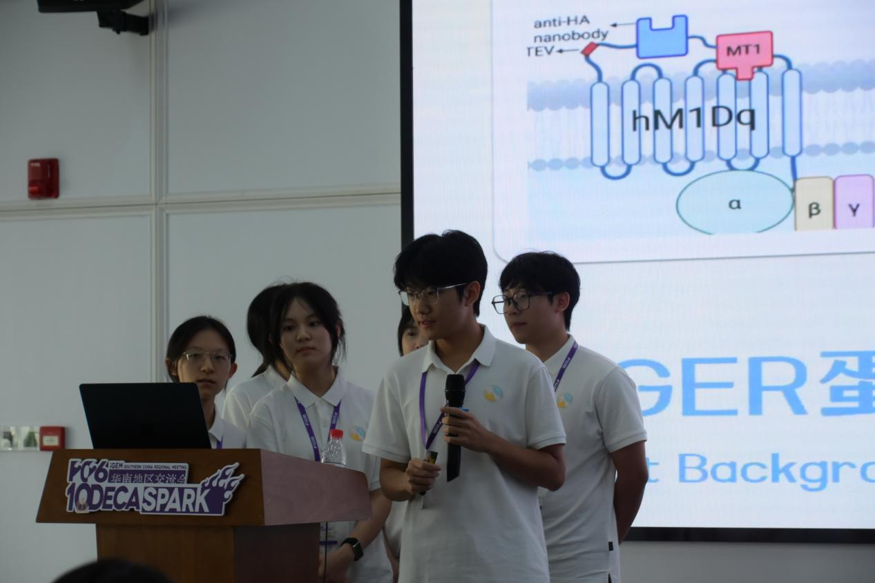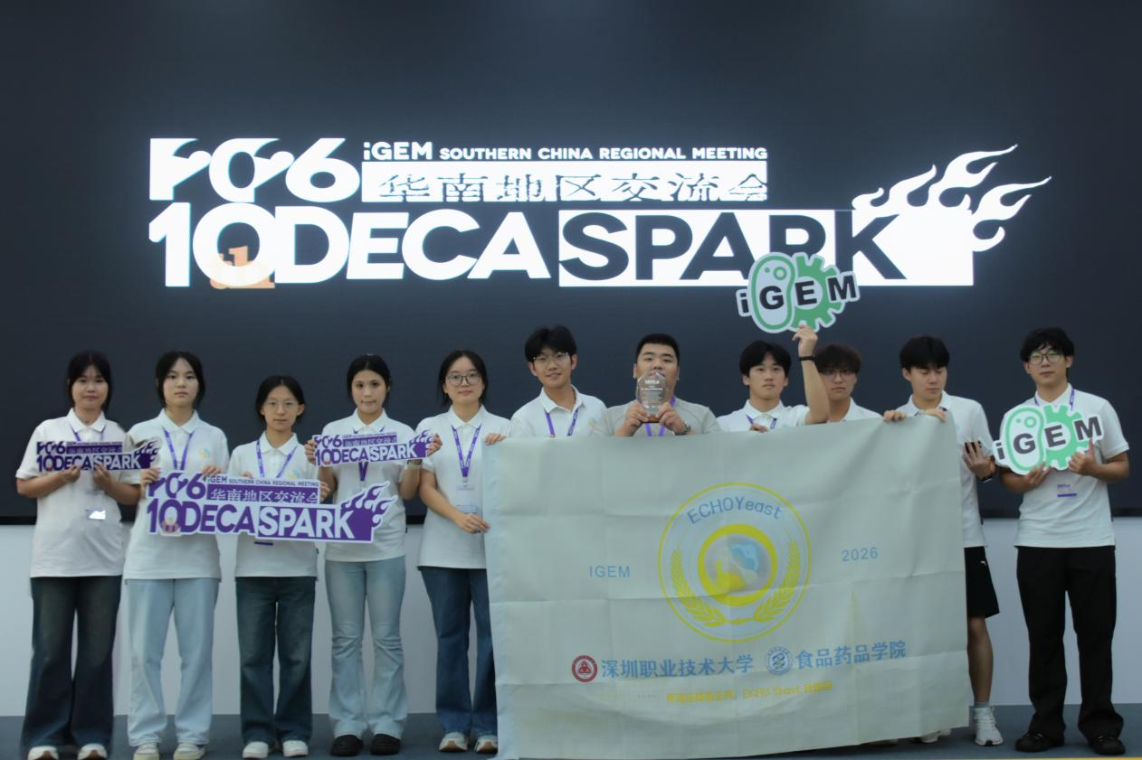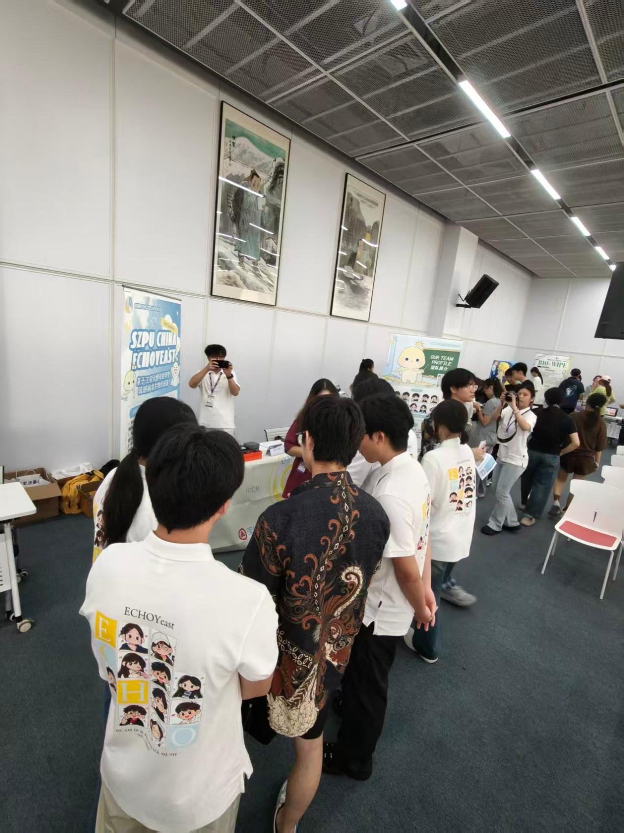
APiC: the first Asia-Pacific iGEM team conference
APiC (Asia-Pacific iGEM Community Conference) was the first Asia-Pacific iGEM team conference, jointly hosted by the Southern University of Science and Technology (SUSTech) and the University of Hong Kong (HKU). Our team took part in both stages — at SUSTech and at HKU — learning from multiple iGEM teams across the Asia-Pacific region and polishing our project together through lectures, mock reviews, project presentations and interactive activities.
SUSTech stage: mock review and project exchange
At SUSTech, we first attended several expert lectures covering frontier advances in synthetic biology, project validation methods and standardized practice. Then iGEM competition staff introduced the competition process and judging criteria online, giving us a clearer understanding of this year's rules and scoring priorities.
The mock review was the highlight of the exchange. We went through the complete formal defense process, reviewing item by item from problem definition and technical route to validation design. The reviewers advised us to focus further on application scenarios, supplement data evidence and pay attention to compliant expression. We recorded these suggestions one by one and marked them as a list for the next round of improvement.
In the project exchange session, we introduced the origins, core mechanism and expected application of the influenza A air-detection project, and also learned about other teams' technical routes and validation ideas. We also studied the design and content organization of each team's poster — from layout and figures to the story line — and gained a good deal of presentation experience.
Interactive activities: making the project “playable, tangible and open to feedback”
We applied to the conference for on-site interactive activities and were given a dedicated space to set up two sessions. The first was question cards designed around the target prizes: other teams could look at our questions according to their own target prize and write down their answers, while we explained on site the design idea behind each card and the judging criteria of concern, collecting cross-team feedback at the same time. The second turned the project design concept into a “Plane War”-style mini-game, in which participants advanced through levels following the story guide and learned about our project in a relaxed atmosphere. Player feedback will also be used to optimize the story pacing and level design. In addition, during exchanges on experimental experience, we swapped many practical tips with other teams on experimental design, quality control and data handling.
HKU stage: lectures and a discussion session with past participants
At the University of Hong Kong, we continued to attend expert lectures and joined a discussion session with past iGEM participants. Everyone exchanged views on what they gained from the competition, teamwork, and the difficulties encountered in advancing projects and how they were solved. The sharing by past participants gave us a more concrete understanding of iGEM's rhythm and priorities. The HKU stage also included a poster display and free-exchange session, where we had in-depth discussions with other teams on project design, validation plans and presentation approaches.
Outcomes and follow-up
APiC was our first time taking part in an Asia-Pacific-level iGEM team conference, and it was also the very first edition. Through the two stages at SUSTech and HKU, we not only learned from frontier lectures and review experience, but also helped more teams learn about our project through the interactive activities we designed ourselves. Next, we will optimize the validation plan and interaction design according to the reviewers' suggestions and what we gained from the exchange, refine the project materials, and continue to stay in contact and cooperate with the other teams.
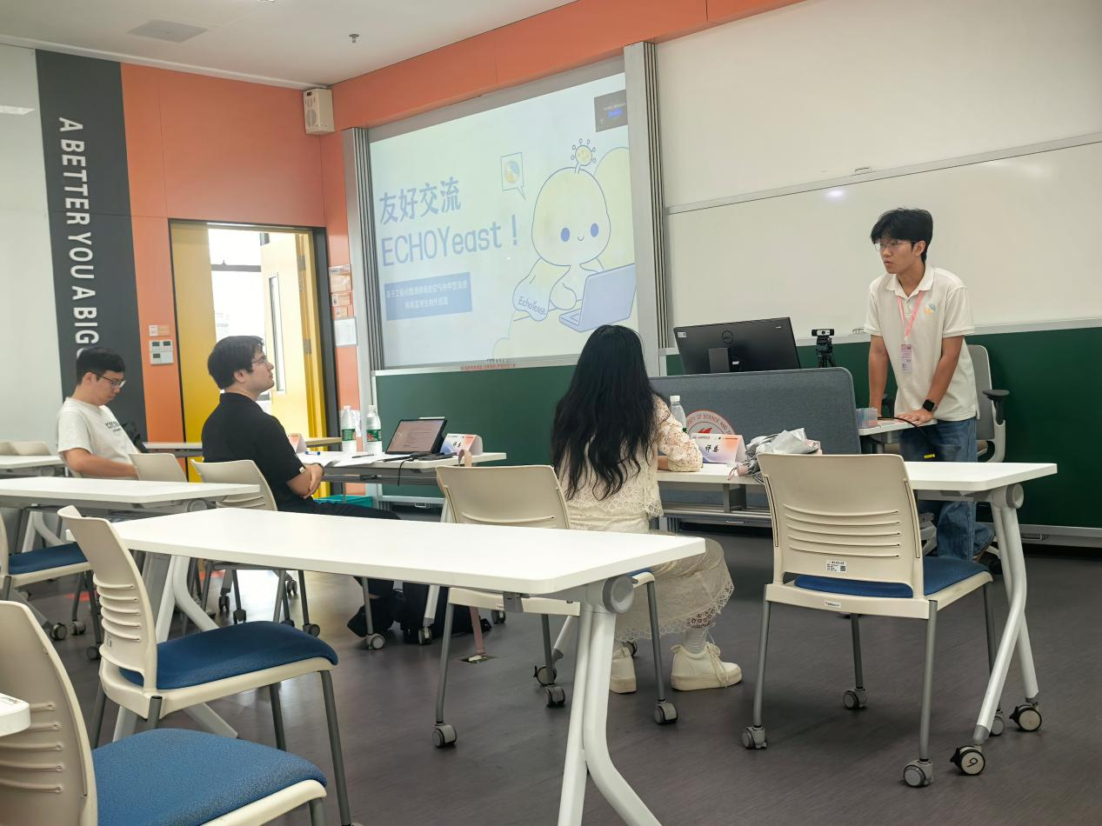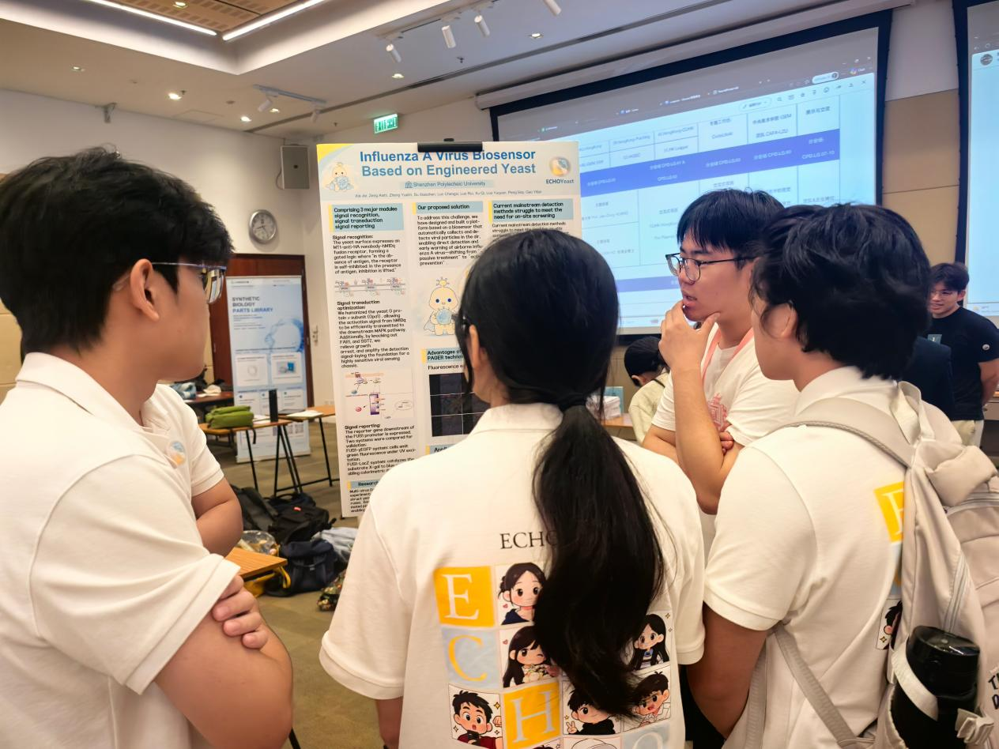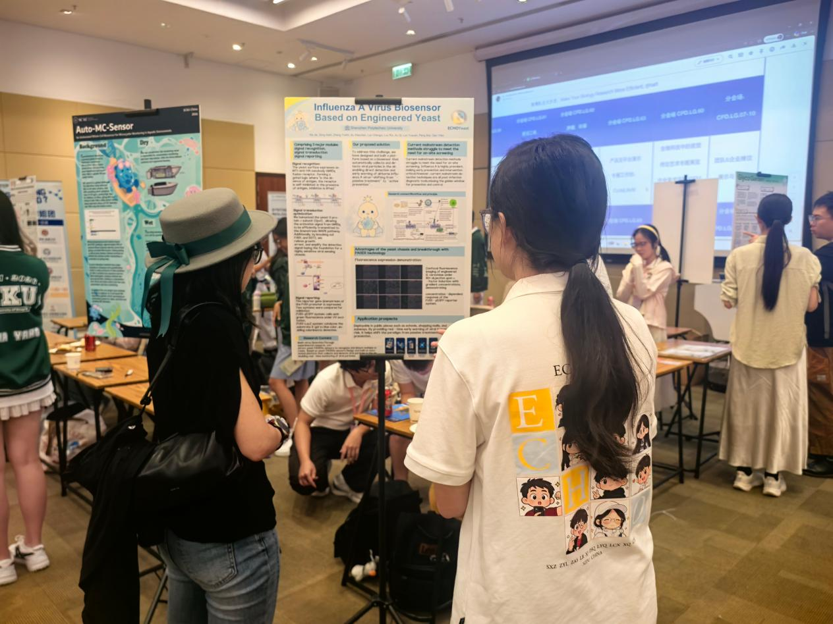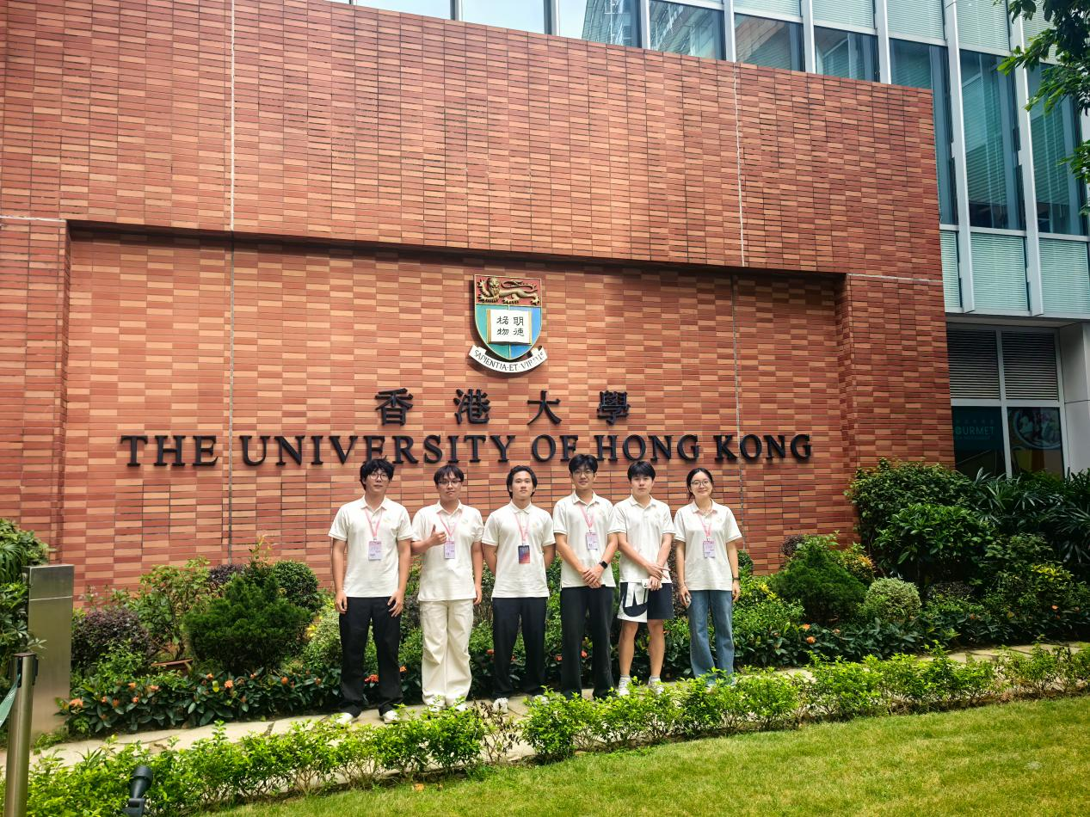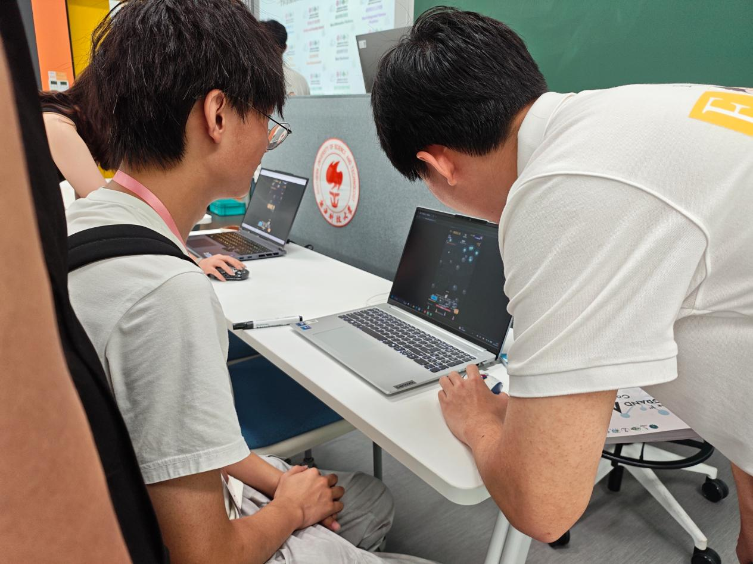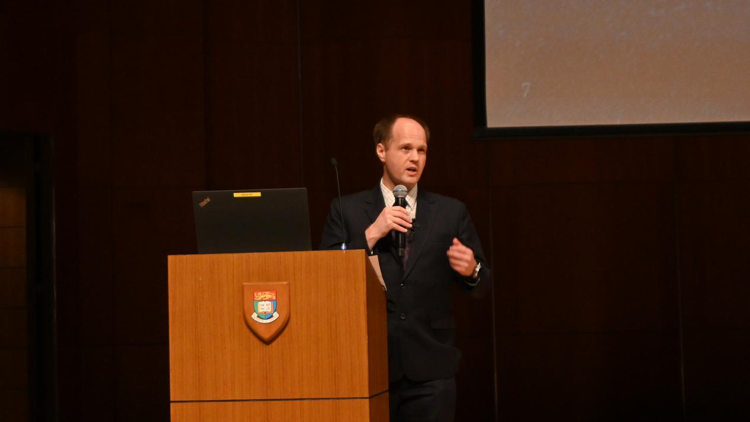

Education
While advancing our project research, we also hoped to bring synthetic biology out of the laboratory and let more people learn about this frontier field. To that end, we gave outreach talks to students of the Shenzhen First Vocational Technical School and to undergraduates of our own 2026 cohort majoring in pharmacy and pharmaceutical engineering technology. In these activities we not only introduced the design ideas of the influenza A air-detection project, but also took the opportunity to explain the basic concepts, research approaches and application prospects of synthetic biology. Many of the students were encountering synthetic biology for the first time; through our explanations they gained an intuitive understanding of “engineering microorganisms to serve human health” and became interested in the field. We hope that through such talks, more people will learn about and understand synthetic biology, and that the project will also accumulate broader social feedback.

iGEM science outreach session for freshmen
The session was delivered jointly by the iGEM student team and our supervising teachers. We started from synthetic biology itself to help the students build a basic understanding: it is not just gene editing, but requires the engineering mindset of “design–build–test–learn” to solve real-world problems in healthcare, environmental governance, new materials development and so on. We used everyday examples to break the stereotype that “synthetic biology is far removed from daily life”, letting the students appreciate that the discipline is both interesting and rigorous.
We introduced research projects, academic competitions, academic conferences and social practice, emphasizing that extracurricular practice needs to be built on a solid foundation in professional courses. Since most of the students had never encountered iGEM, we introduced this global synthetic biology student competition: it is not limited to wet-lab work but also covers hardware construction, modeling, human practices, wiki development and poster defense, and can develop a comprehensive skill set covering literature research, experimental operation, stakeholder interviews and teamwork.
We focused on introducing the airborne influenza A virus biosensor project, explaining its positioning for infection-risk early warning in enclosed spaces, and shared our interview experience with experts in disease control, the health commission, hardware development and synthetic biology, showing that expert opinions were genuinely applied to project iteration. During the activity we distributed an influenza A prevention handbook written by the team, linking laboratory research with public health needs; the supervising teachers also added explanations of the relationship between professional coursework and science-innovation practice.
In terms of outcomes, most participants built a basic understanding of synthetic biology, the iGEM competition and the influenza A detection sensor project, gained preliminary knowledge of genetic engineering, and dispelled the fixed impression that “research is very distant from young learners”. The activity also completed influenza A prevention outreach and raised the students' awareness of respiratory infectious disease prevention. The shortcoming was that, limited by the length of the talk, we could not explain the experimental principles and hardware details in depth, and the handbook was distributed in bulk without item-by-item explanation on site. Going forward we plan to open a consultation channel for interested participants, hold small themed salons, and collect feedback on the handbook to iterate subsequent outreach materials.
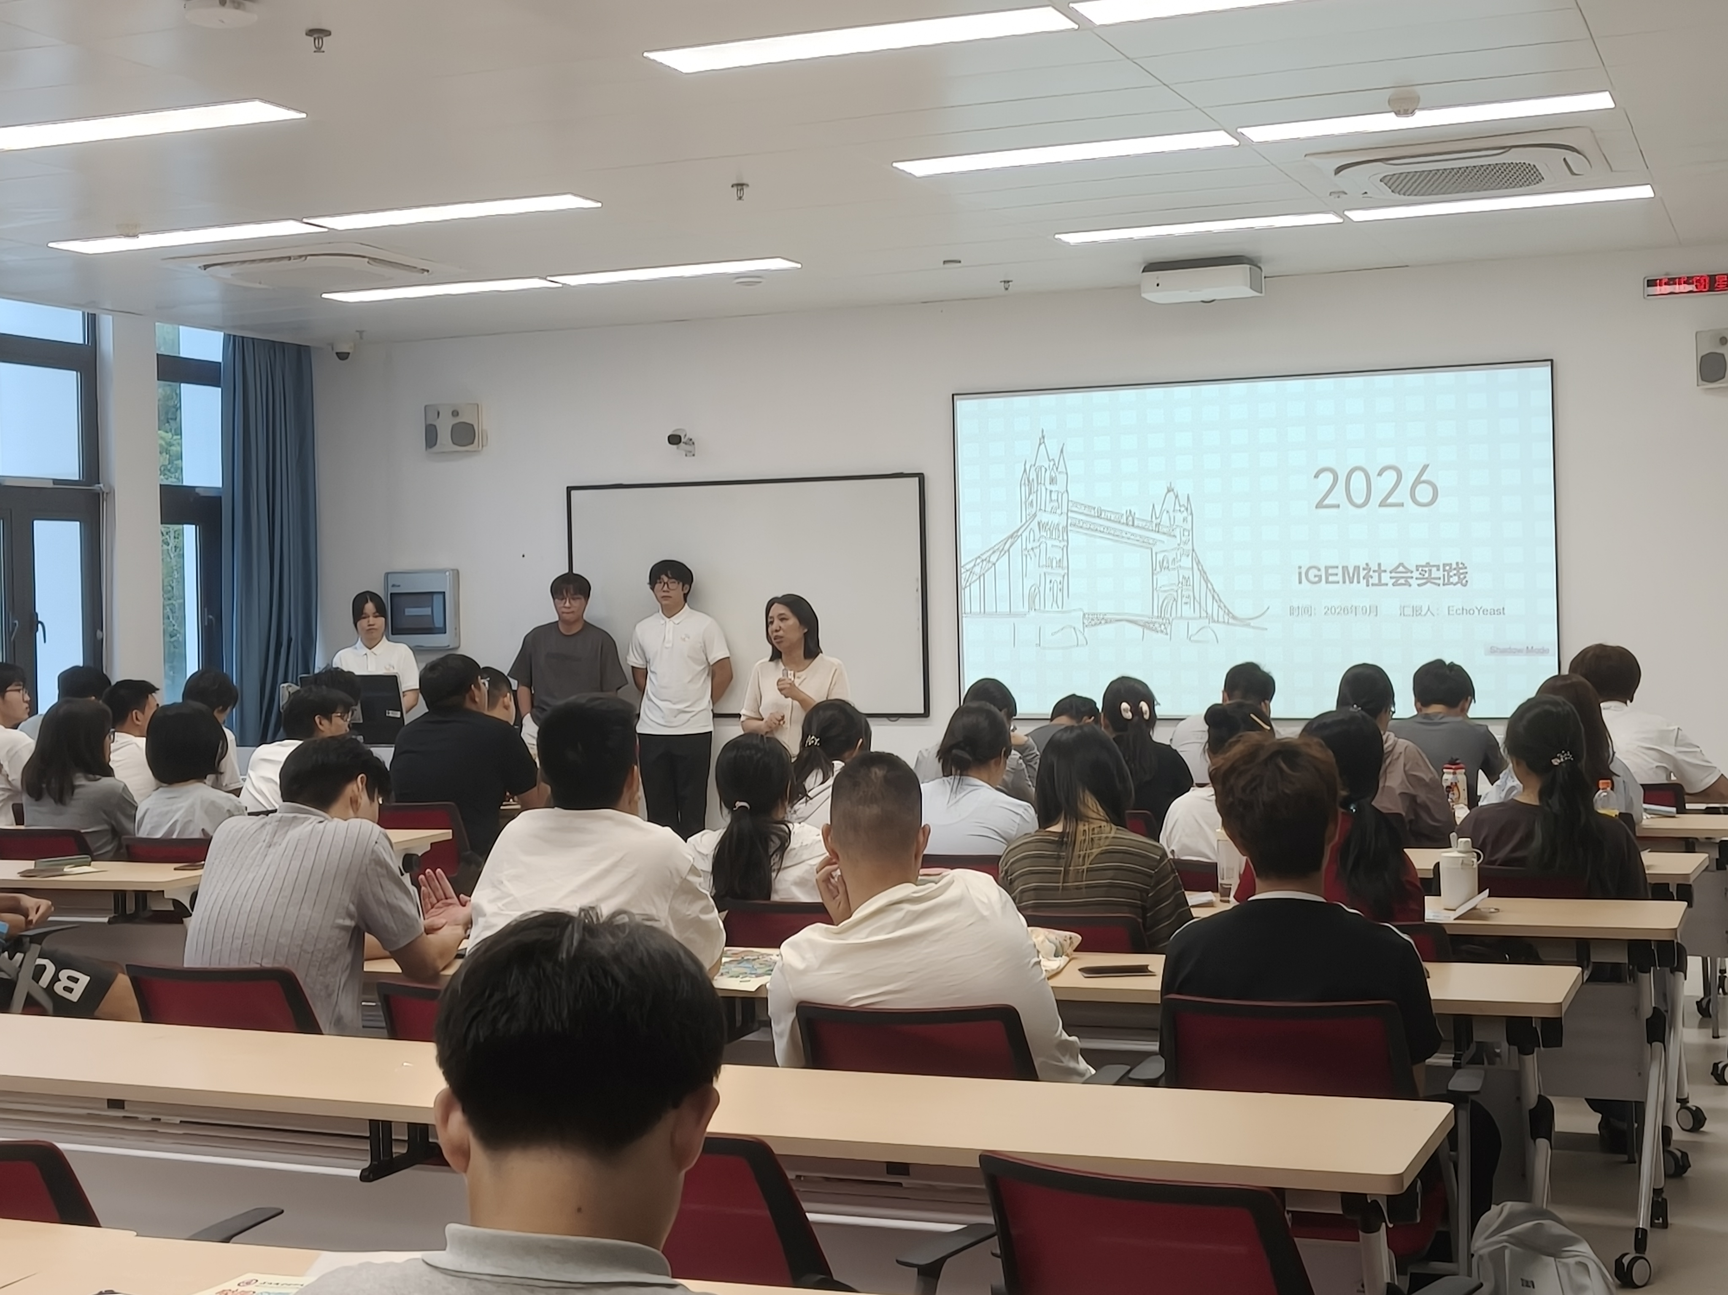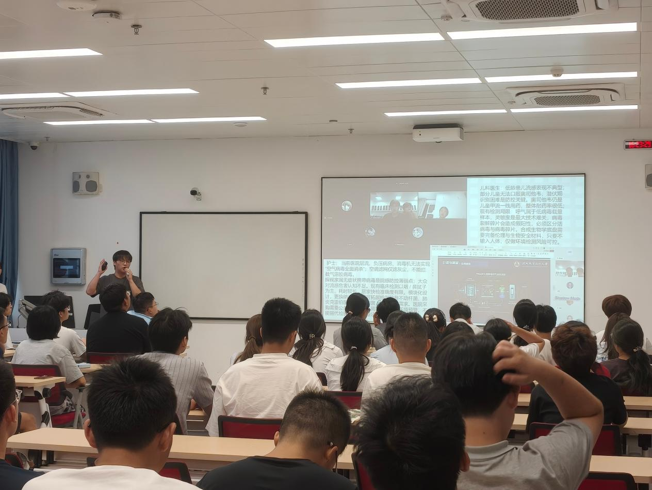
Synthetic biology outreach talk at a secondary vocational school
We gave a talk to students majoring in pharmaceutical-related fields at the Shenzhen First Vocational Technical School, presented by team members. These students focus on traditional pharmaceutical processes in their daily studies, rarely have the chance to encounter cutting-edge synthetic biology, and easily form a stereotype of life-science research as “abstruse and hard to understand”.
We likewise prioritized synthetic biology in our outreach, explaining its application prospects in drug synthesis, biological detection and other directions in the context of the current state of the pharmaceutical industry, so that the students could see the frontier directions their major can extend into. Through accessible examples, we showed that synthetic biology combines playful creativity with scientific rigor, dispelling the students' fear of frontier research and letting them know that young students can likewise carry out hands-on synthetic biology innovation projects.
We introduced the iGEM competition and the value of science-innovation practice for young people, explaining that the competition is not just laboratory experiments but a science-innovation activity combining experiments, hardware, design and social research. In the project introduction, we used the airborne influenza A virus biosensor as an example, explaining the project's inspiration, background, experimental concept, hardware design, wiki and IP visual design; team members with a pharmacy background also shared how they taught themselves programming out of personal interest, showing that interdisciplinary skills are not exclusive to students of the related major.
We also shared the team's human practices, academic exchanges and competition experience, and distributed custom merchandise to boost on-site engagement. In the interactive session, we answered the students' questions and collected genuine suggestions from end users, such as improving device portability and shortening detection time.
For the participating students, this talk brought them close to research content related to synthetic biology, let them see in advance the research and industry directions corresponding to their major, helped them look beyond the limits of textbooks and deepened their well-rounded understanding of their own field. They realized that research is not only test-tube experiments but also includes programming, design and science communication; combined with the public-health-oriented project case, they also appreciated the value of technology in solving real social problems, and some students began to think about the connection between personal interests and future major choices. For the iGEM team, explaining the project clearly to a non-specialist audience forced us to reorganize and simplify the complex technical logic, deepening all members' understanding of the project as a whole; the suggestions raised by participants, such as portability and detection time, also became important references for prototype iteration and refinement of application scenarios. The shortcoming was that, with limited time, we could not hold an in-depth hands-on workshop. In the future we hope to build a regular science-communication channel for young audiences.
